**Day-1 | Fundamentals of DevOps**

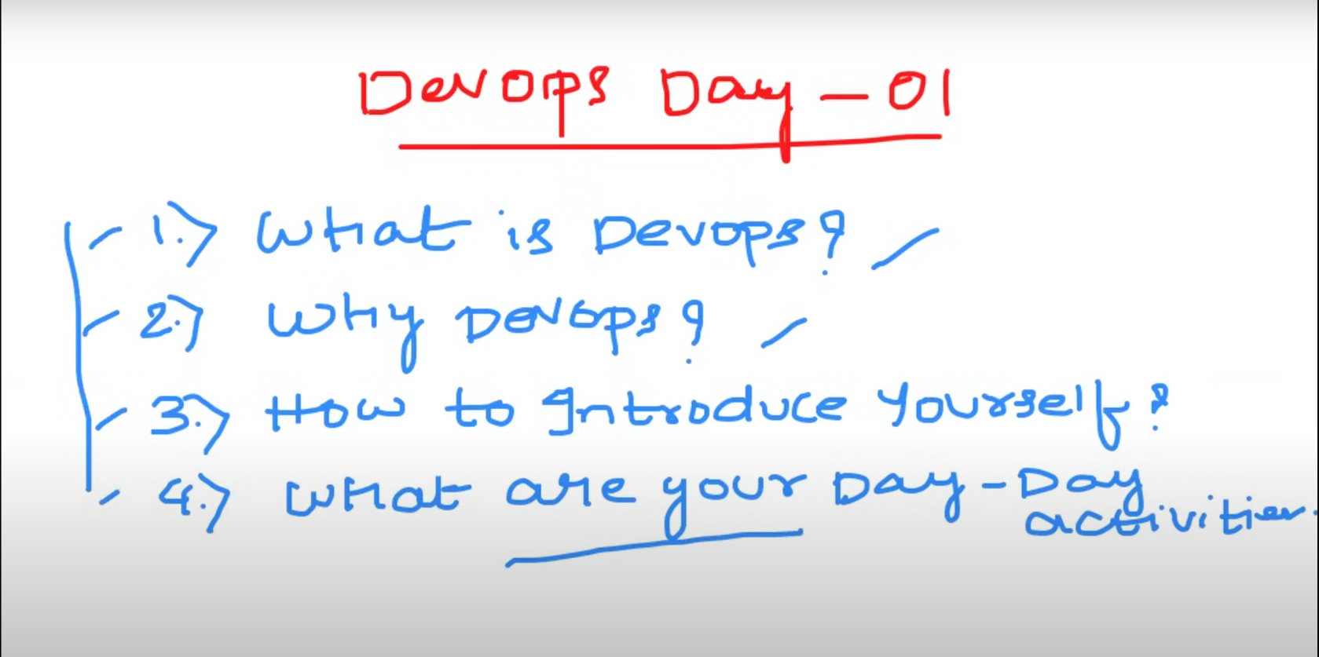

DevOps: is a culture that improves organisational ability to **deliver** the application.

E.g. example.com will take 10 days (v1 🡪 v2)

You’ll deliver the same in hours or 1-2 days 🡪 this is possible because of devOps.

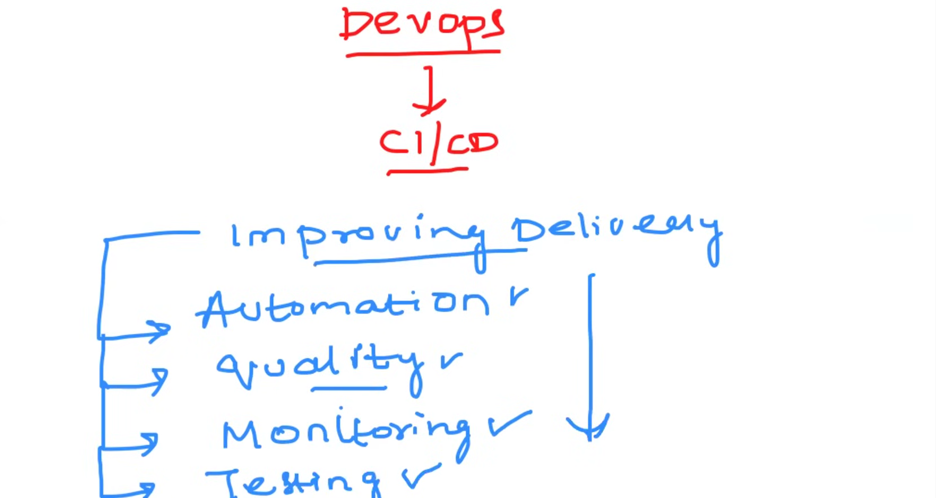 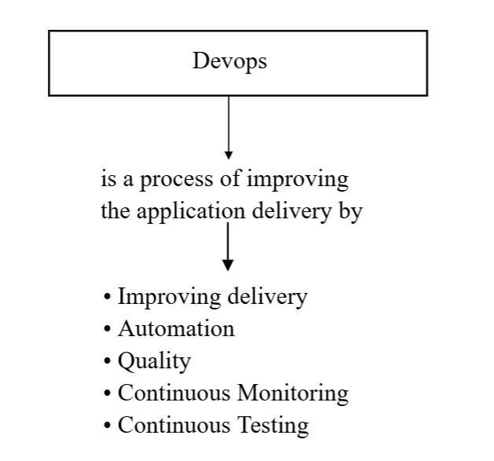

Why devOps?

Before 10 years scenario 🡪

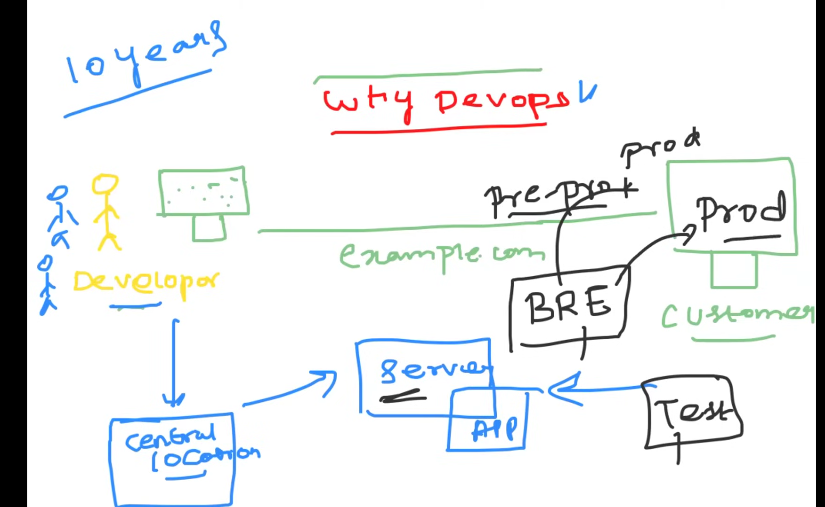

BRE 🡪 Build and release engineer.

System Administrator.

Server Admin.

**End goal is to deliver application from developer laptop to customer.**

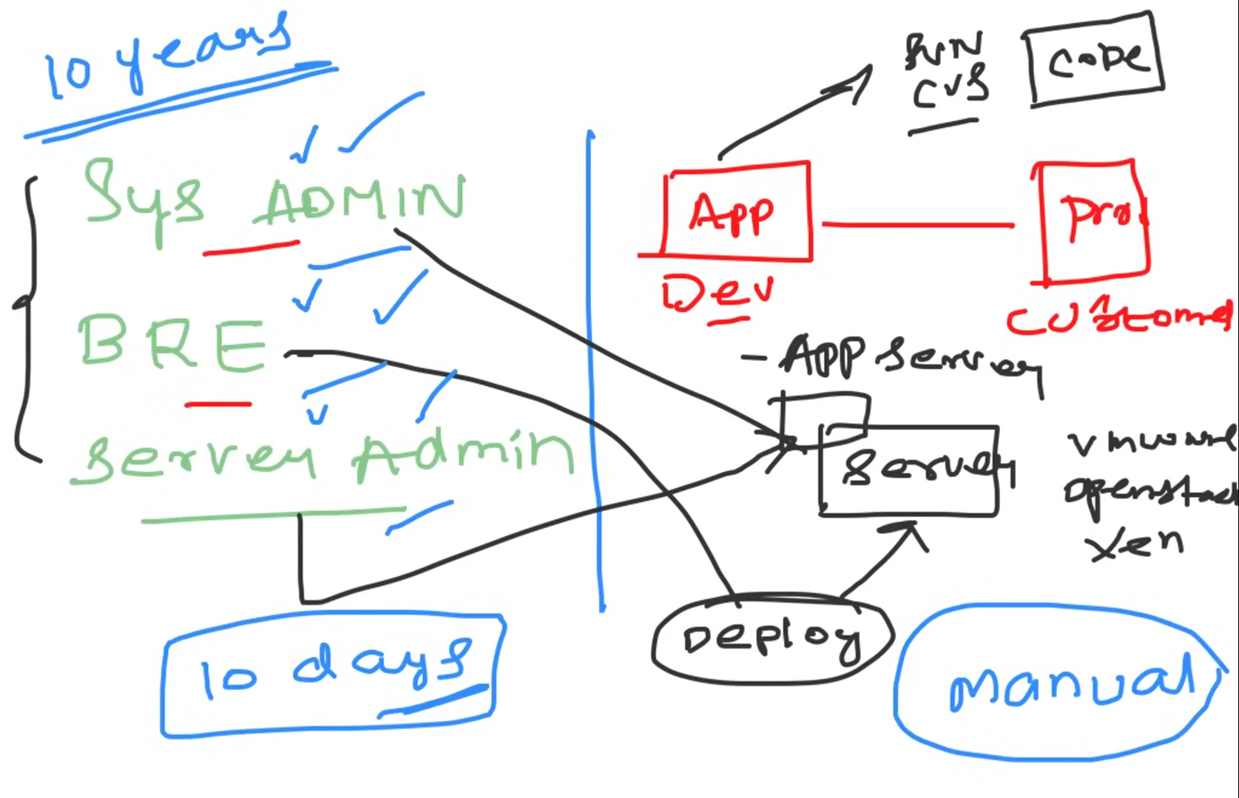

All deployment process was manual on real time it might take 10 days to one month or more

To overcome this devOps comes into play. By the help of devops methodology this time will reduce by 80% and continuous delivery is possible

**DevOps is a software development practice that combines development and operations to improve the speed and reliability of software delivery**

**Day-2 | Improve SDLC with DevOps**

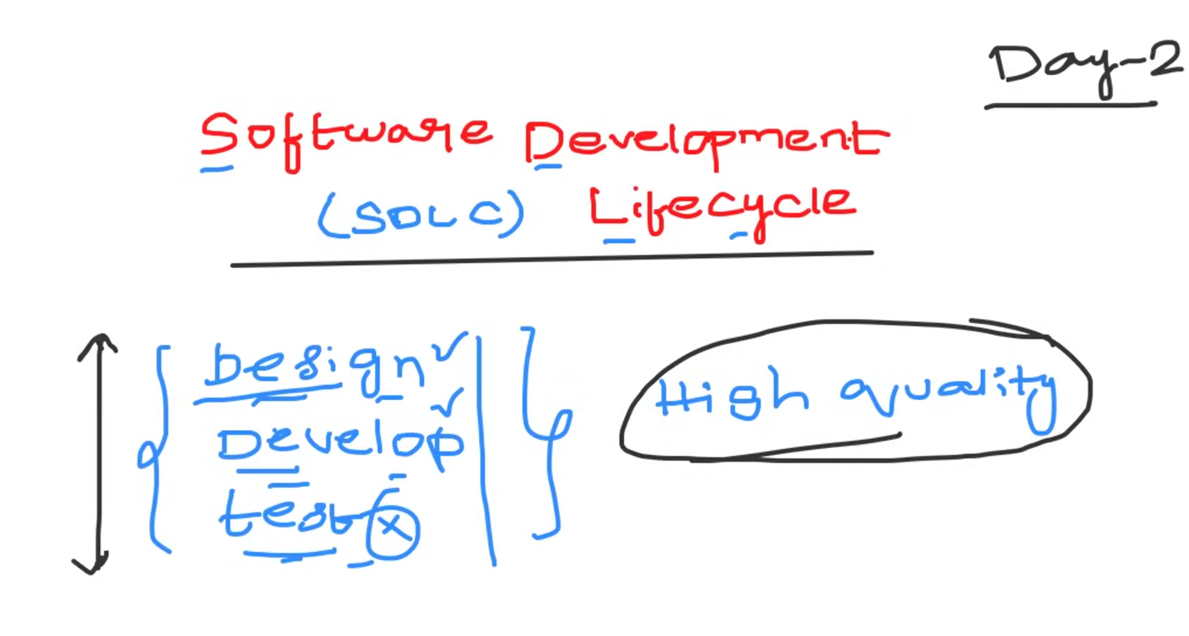

Software Development Lifecycle is a process followed by industries to **design, develop and test high quality product.**

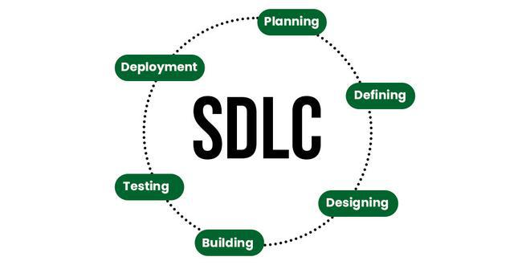

The Software Development Life Cycle (SDLC) is a structured process that outlines the various stages of software development. Here’s a breakdown of the key phases:

**1. Planning**

Establish project goals, scope, and feasibility. Identify stakeholders and allocate resources. Develop a project timeline.

**2. Designing**

Create a blueprint for the system, detailing architecture, interfaces, and components. Include high-level and detailed designs to guide development.

**3. Defining (Requirements Analysis)**

Gather and document detailed requirements through stakeholder input. Specify what the software must achieve to meet user needs.

**4. Building (Implementation)**

Develop the actual software by writing code based on design specifications. Integrate different components and functionalities.

**5. Testing**

Conduct various tests (unit, integration, system) to identify and fix bugs or issues. Ensure the software meets quality standards and requirements.

**6. Deploy**

Release the software to a production environment. This includes installation, configuration, and making it available for users.

Each of these phases builds on the previous one, contributing to the overall success of the software project.

**Interview question**

**As a DevOps engineer, the focus is typically on the following key pillars of the Software Development Life Cycle (SDLC):**

**1 Building 2 Testing 3 Deployment**

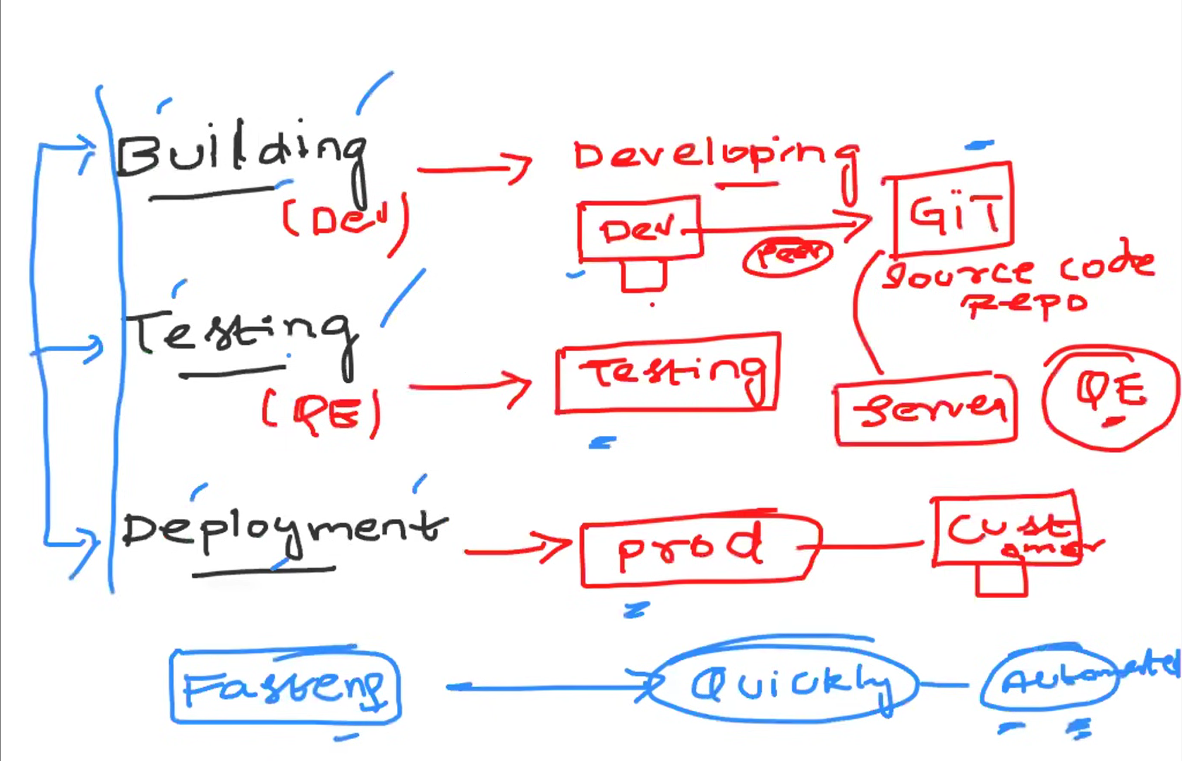

**Day-3 | Virtual Machines Part-1**

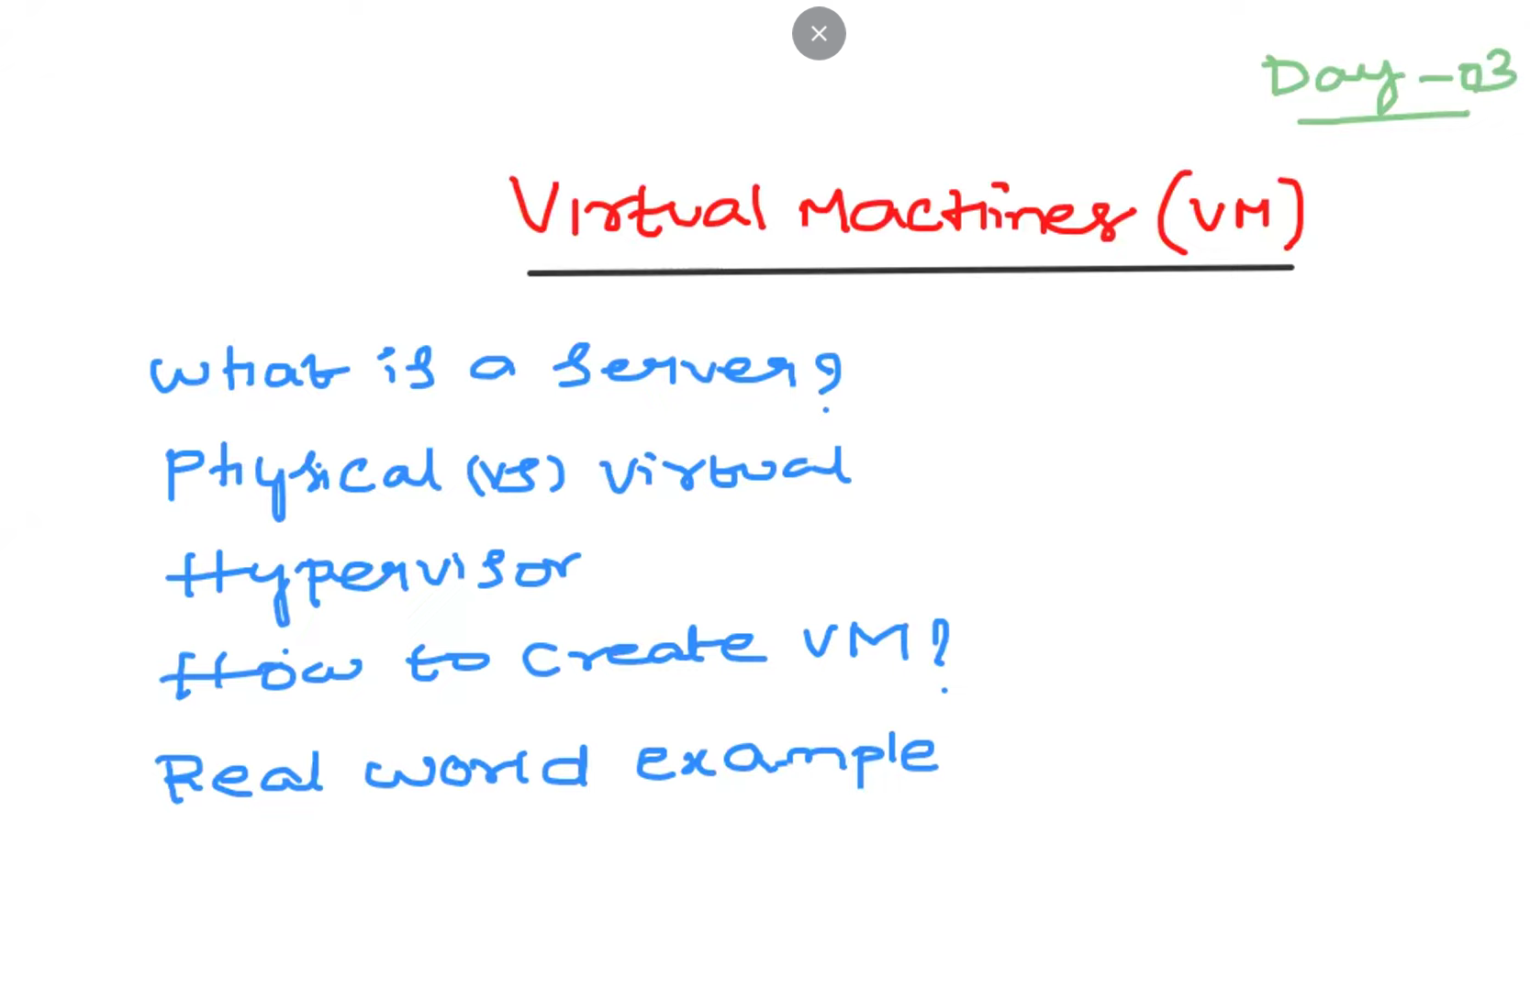

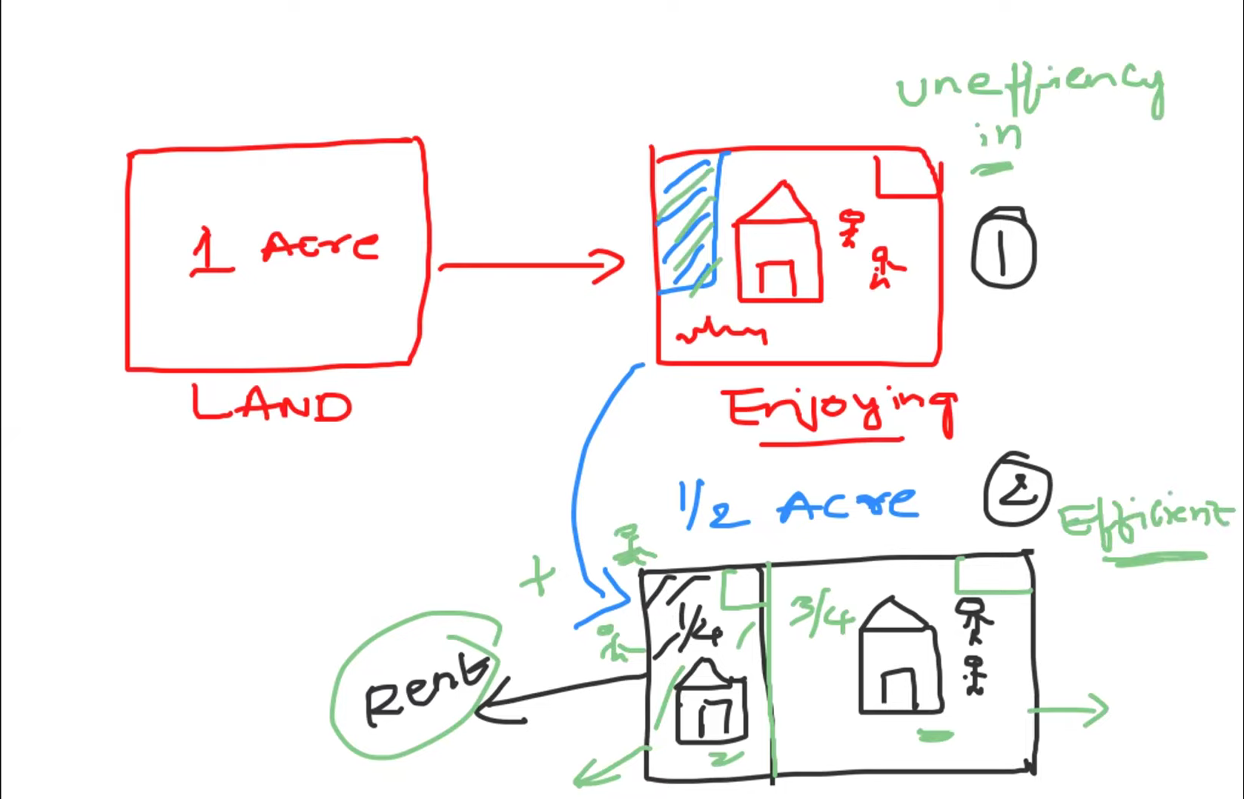

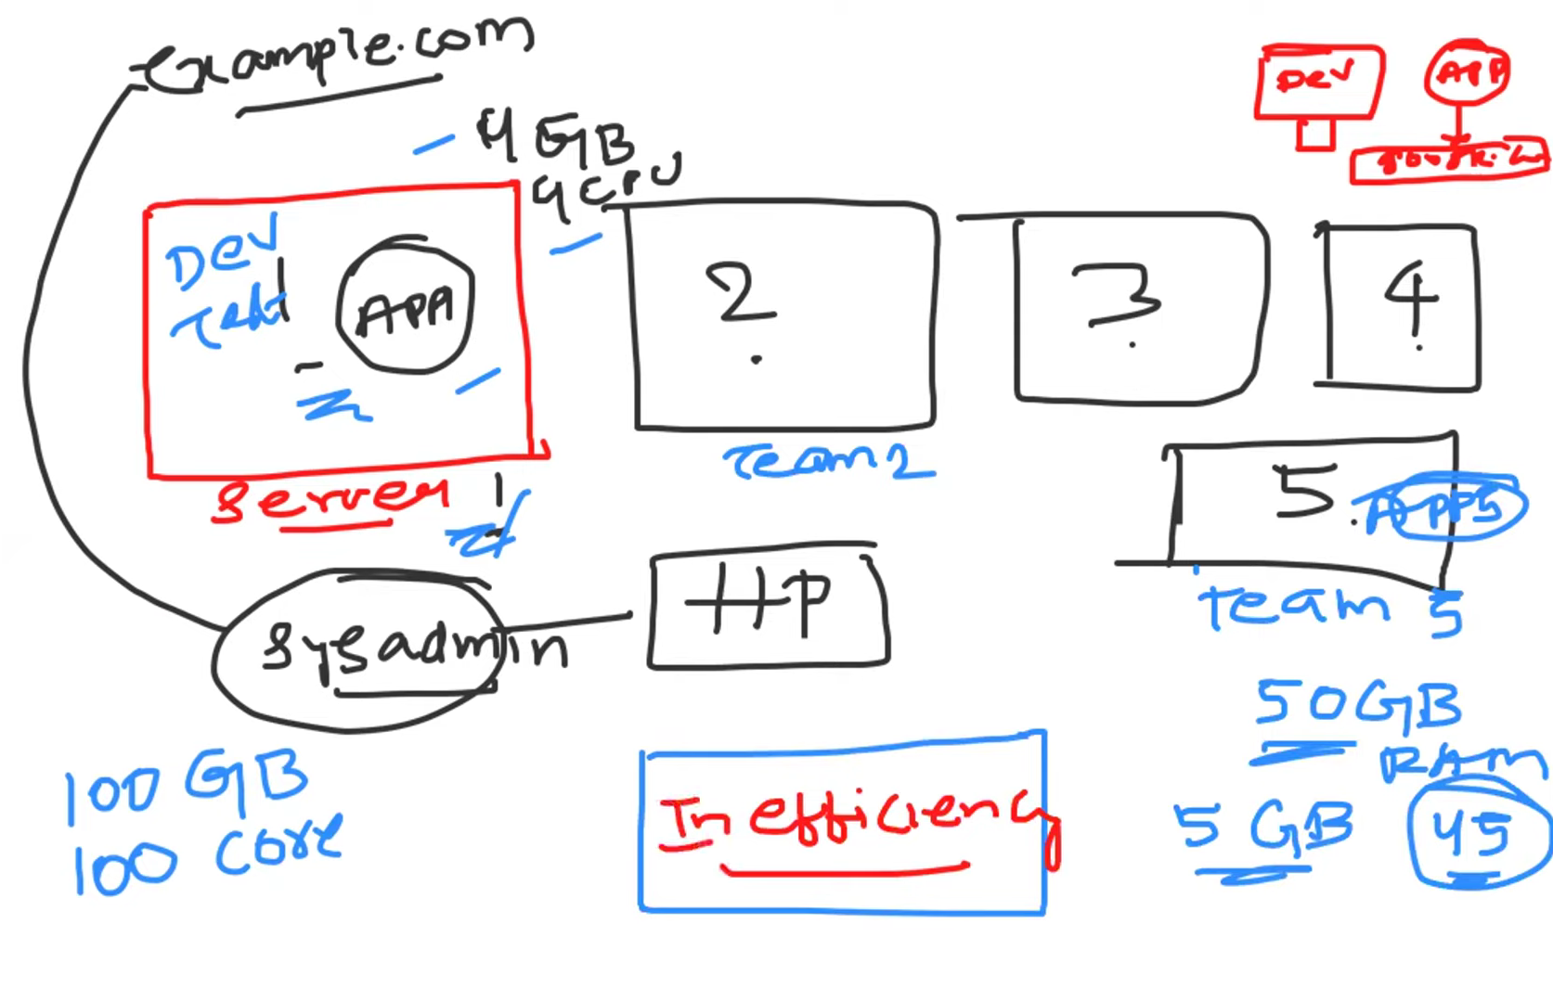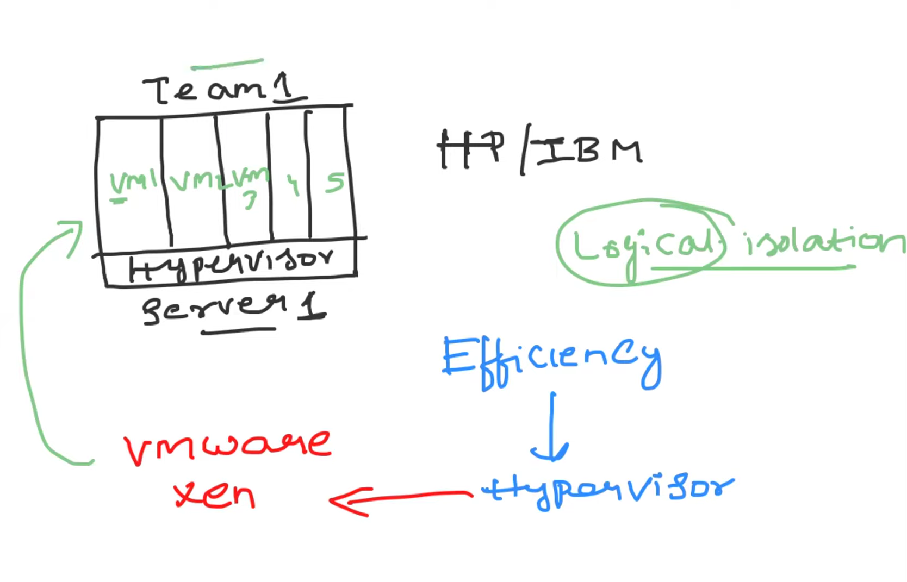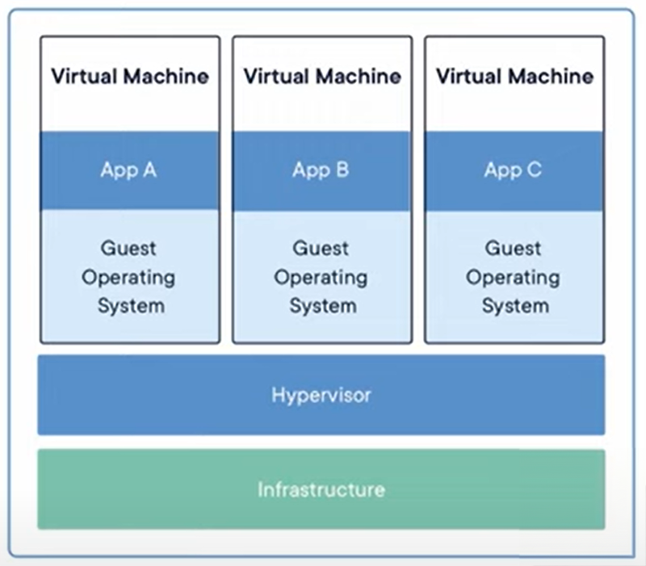

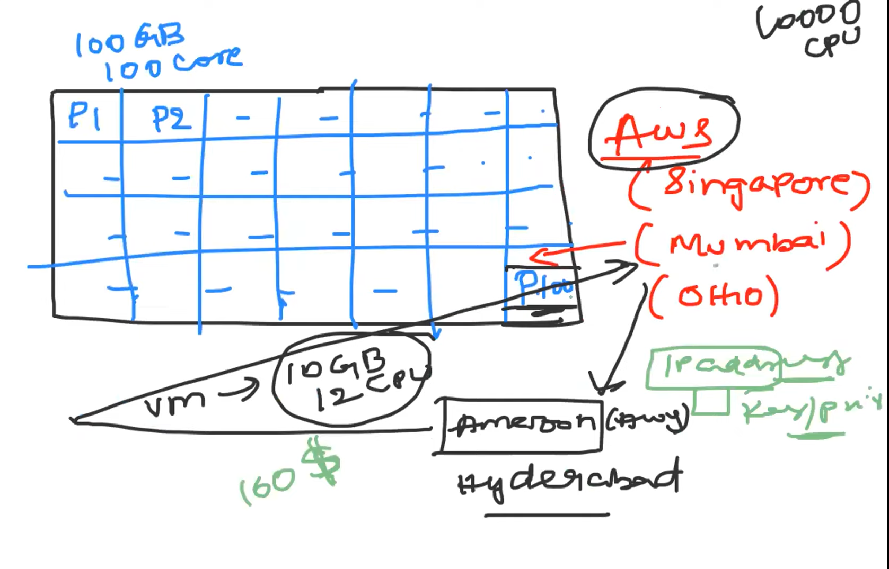

**Day-4 | AWS & Azure - How to Create Virtual Machines**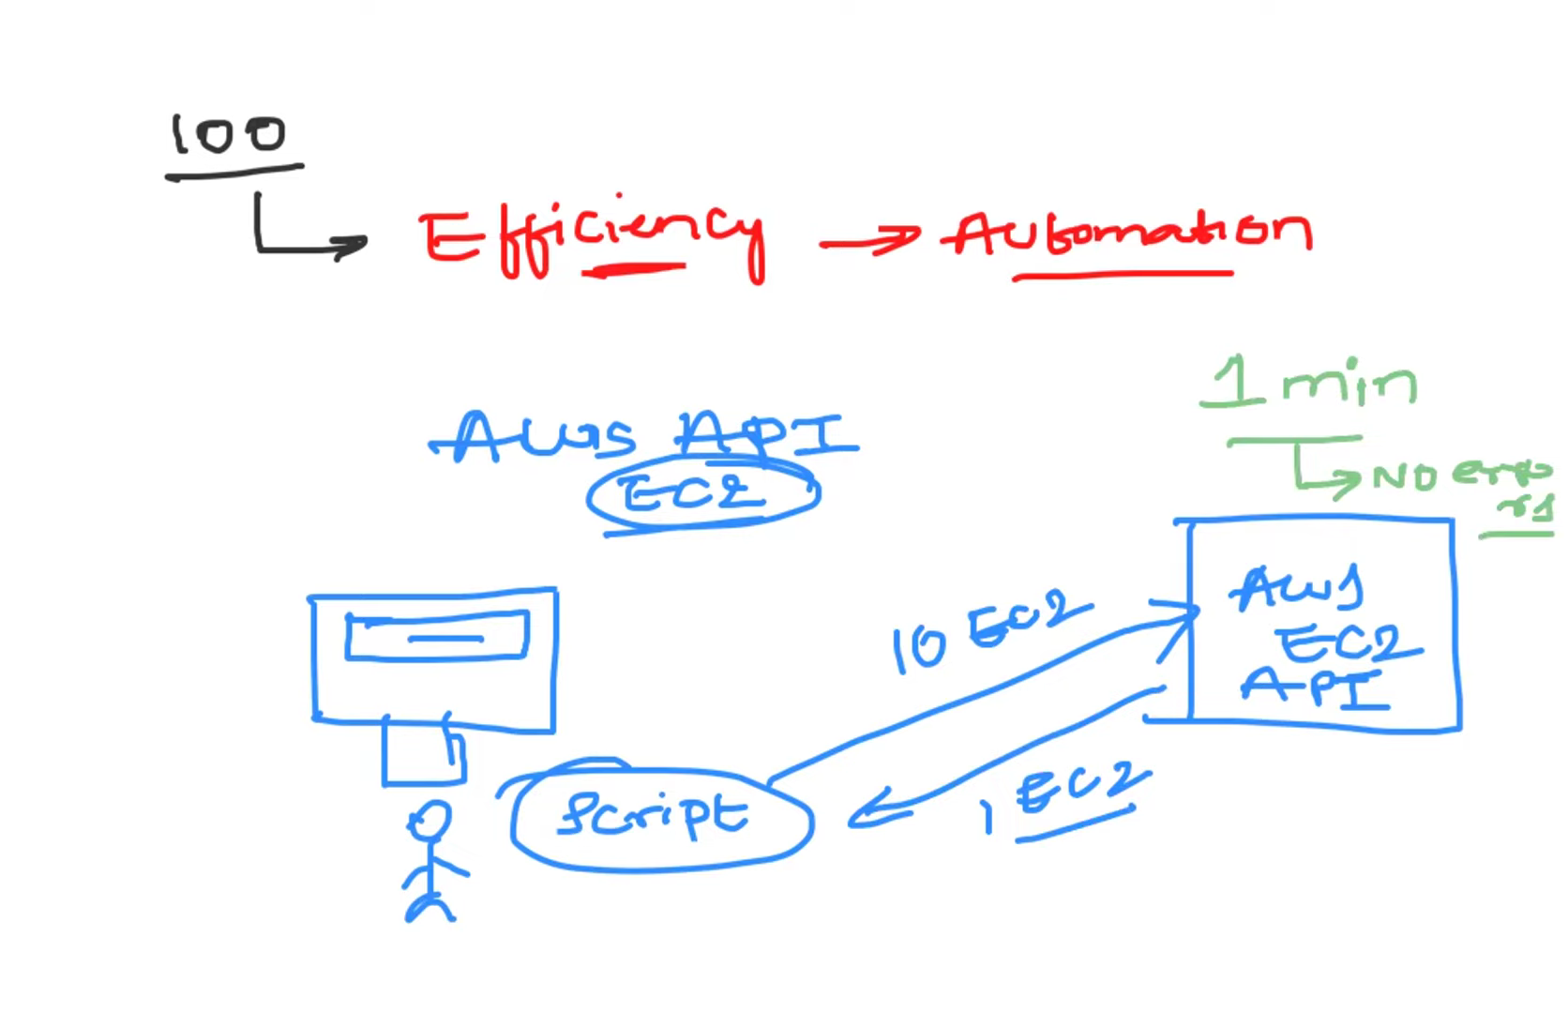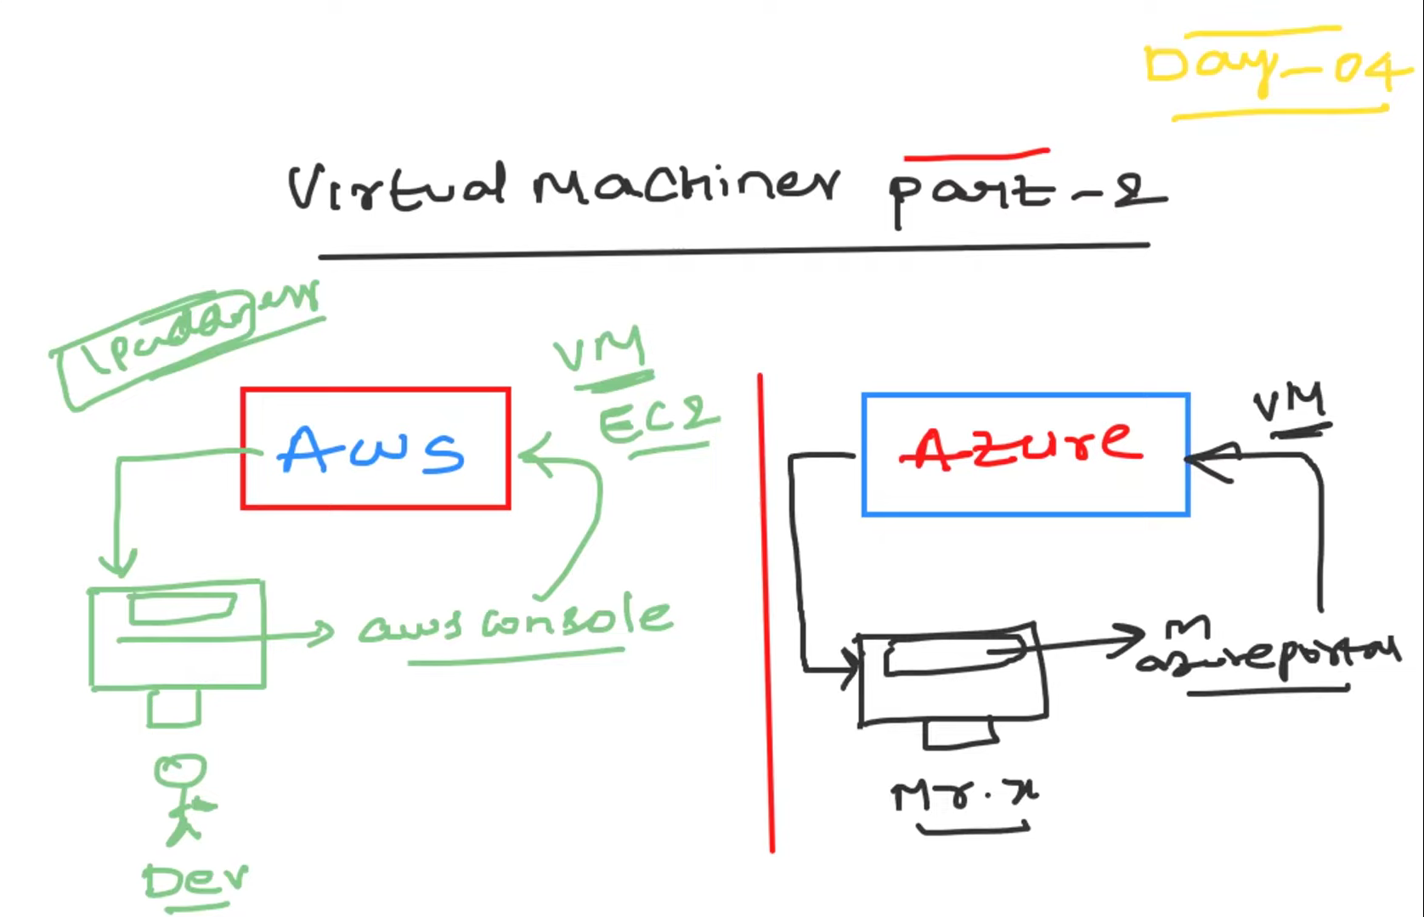

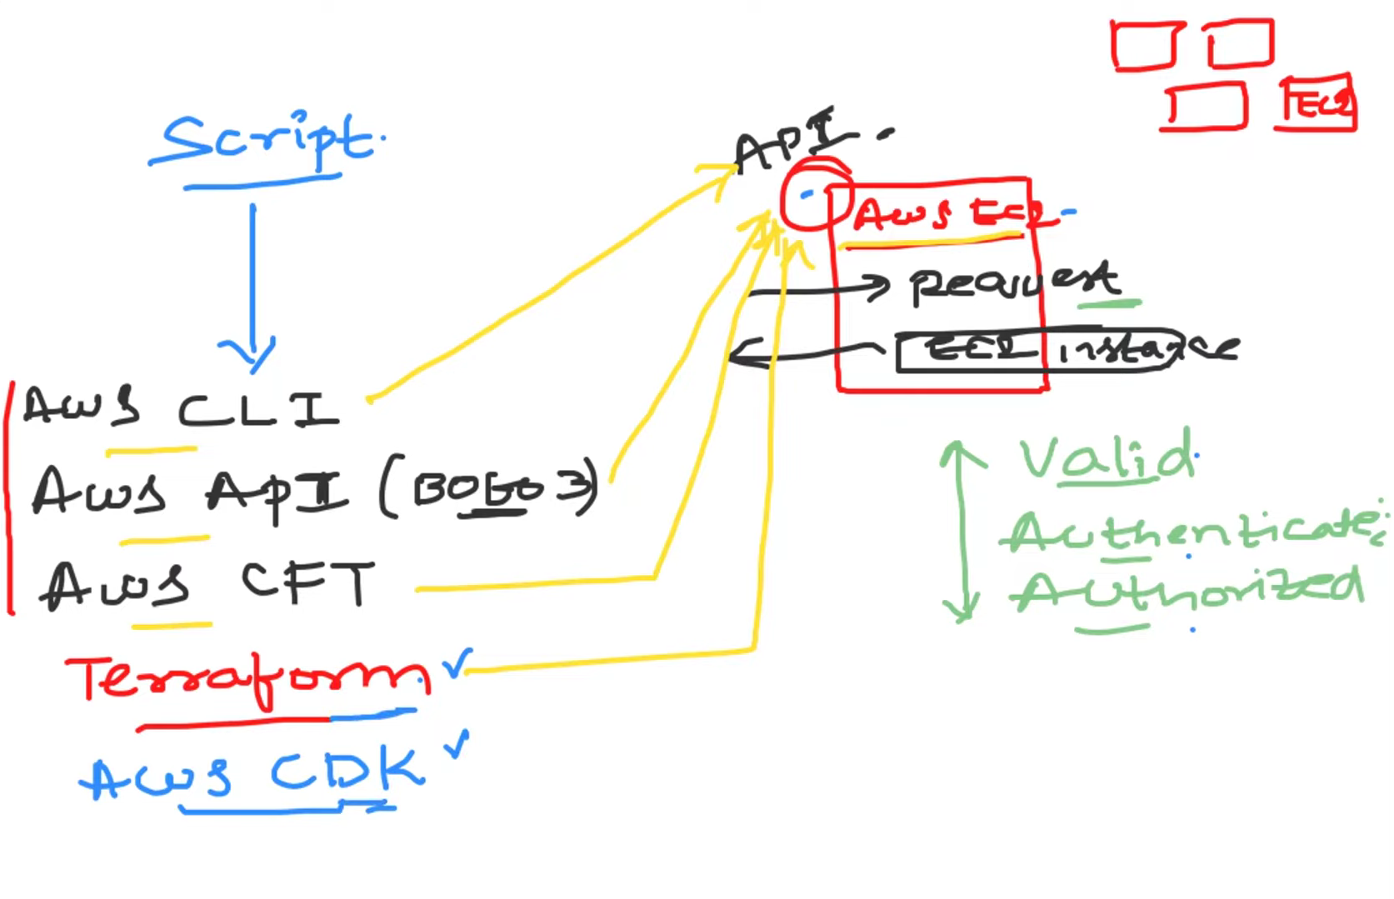

**1. AWS CLI (Command Line Interface): A tool that allows you to interact with AWS services from the command line. It enables you to manage AWS resources and automate tasks using scripts.**

**2. AWS API (Boto3): Boto3 is the official AWS SDK for Python. It provides a Python interface to AWS services, allowing developers to write Python scripts to create, manage, and interact with AWS resources programmatically.**

**3. AWS CFT (CloudFormation Template): AWS CloudFormation allows you to define and provision AWS infrastructure as code. CFTs are JSON or YAML formatted text files that describe the resources and configurations needed to deploy applications in AWS.**

**4. AWS CDK (Cloud Development Kit): AWS CDK is an open-source software development framework that allows you to define cloud infrastructure using familiar programming languages like TypeScript, JavaScript, Python, Java, and C#. With CDK, you can create reusable components (called constructs) to define and provision AWS resources programmatically. This approach enables developers to use high-level abstractions and leverage the full power of their programming language, making infrastructure management more intuitive and scalable.**

**Day-5 | AWS CLI Full Guide**

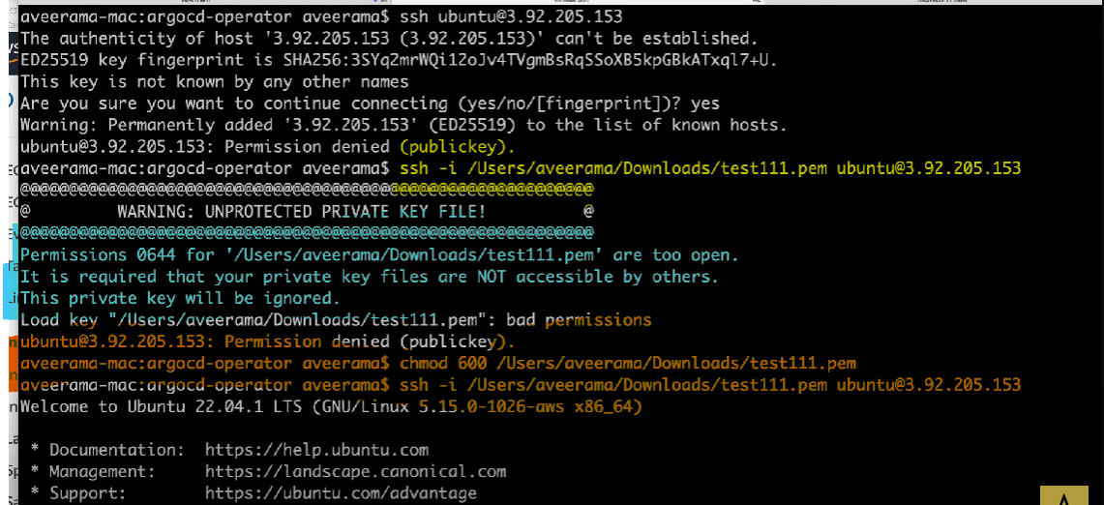

ssh -i /User/aveerama/Downloads/test111.pem 🡪 -i stands for identity   
permission is denied because of test11.pem file are too open 🡪 the test111.pem file having executable permission so any user can access that pem file and this file contains sensitive data of user. So we are changing permission of pem file using below shell command

chmod 600 /User/aveerama/Downloads/test111.pem 🡪permission changed to 600

**600 means you can read and write the file or directory and other users have no access to it. Suitable for private text files.**

**AWS CLI**

**You need to download aws cli from official page and authenticate with access key and secret key**

**To configure access key with cli**

**Command :-> aws configure**

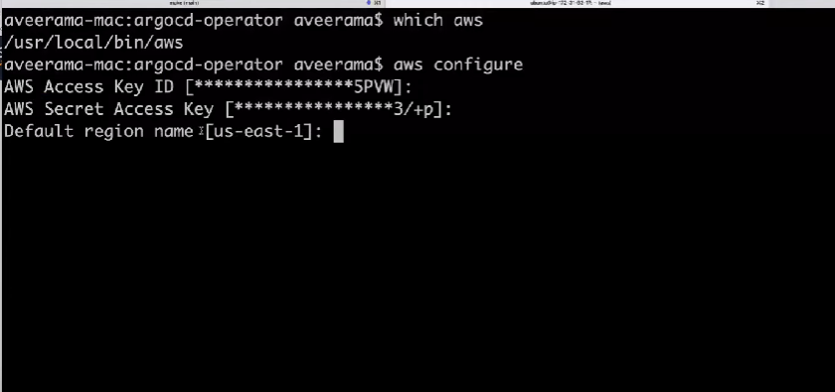

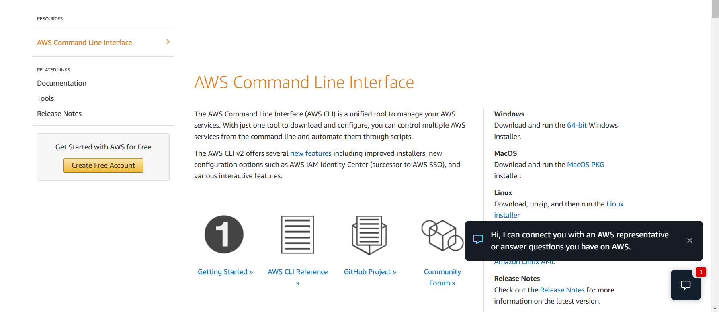

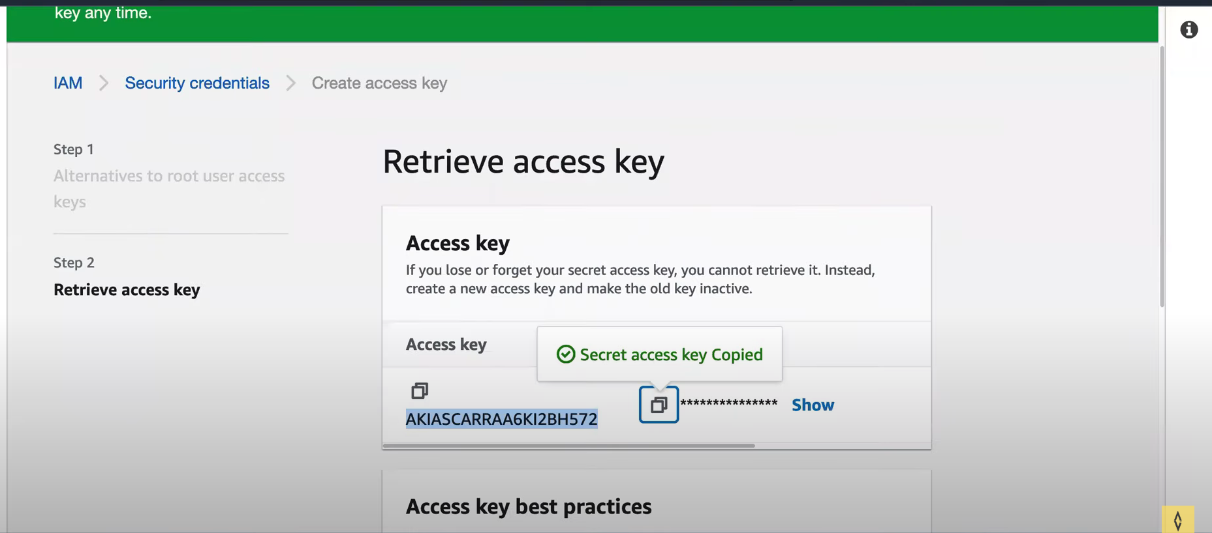

**Day-6 | Linux & Shell Scripting**

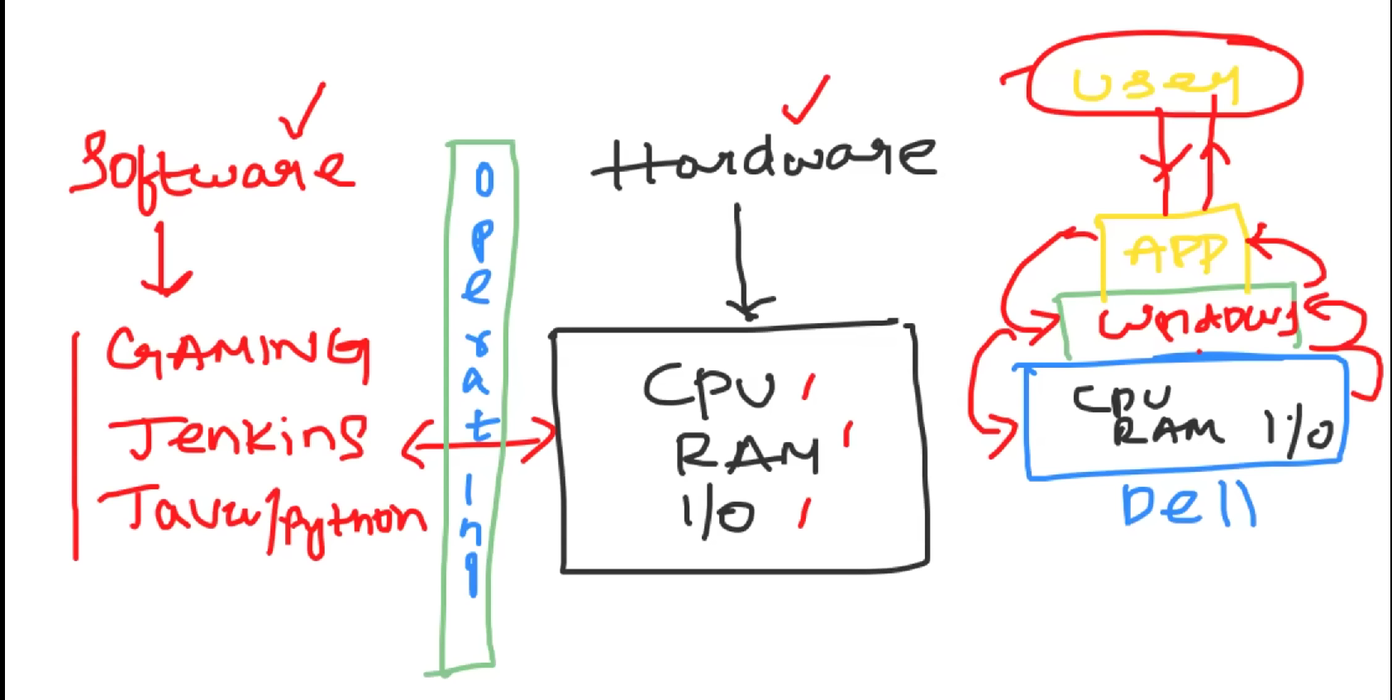

**Why Linux is used over windows OS?**

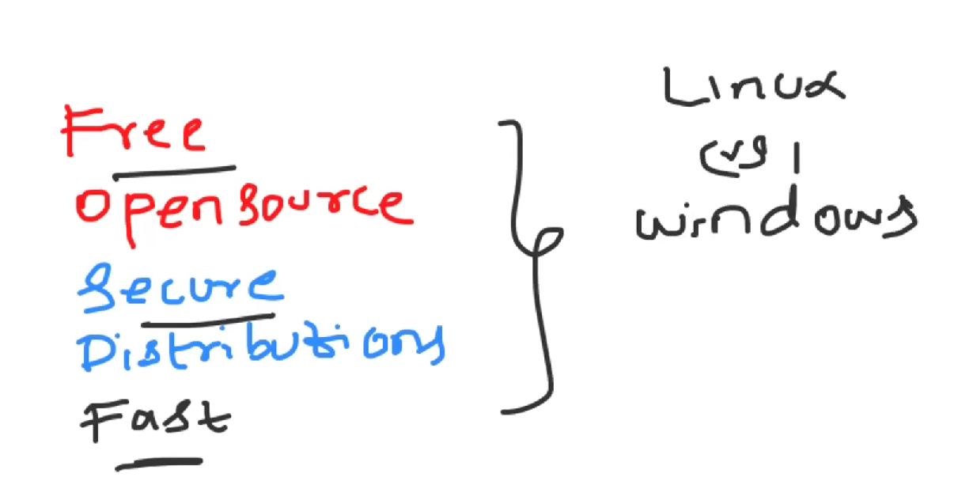

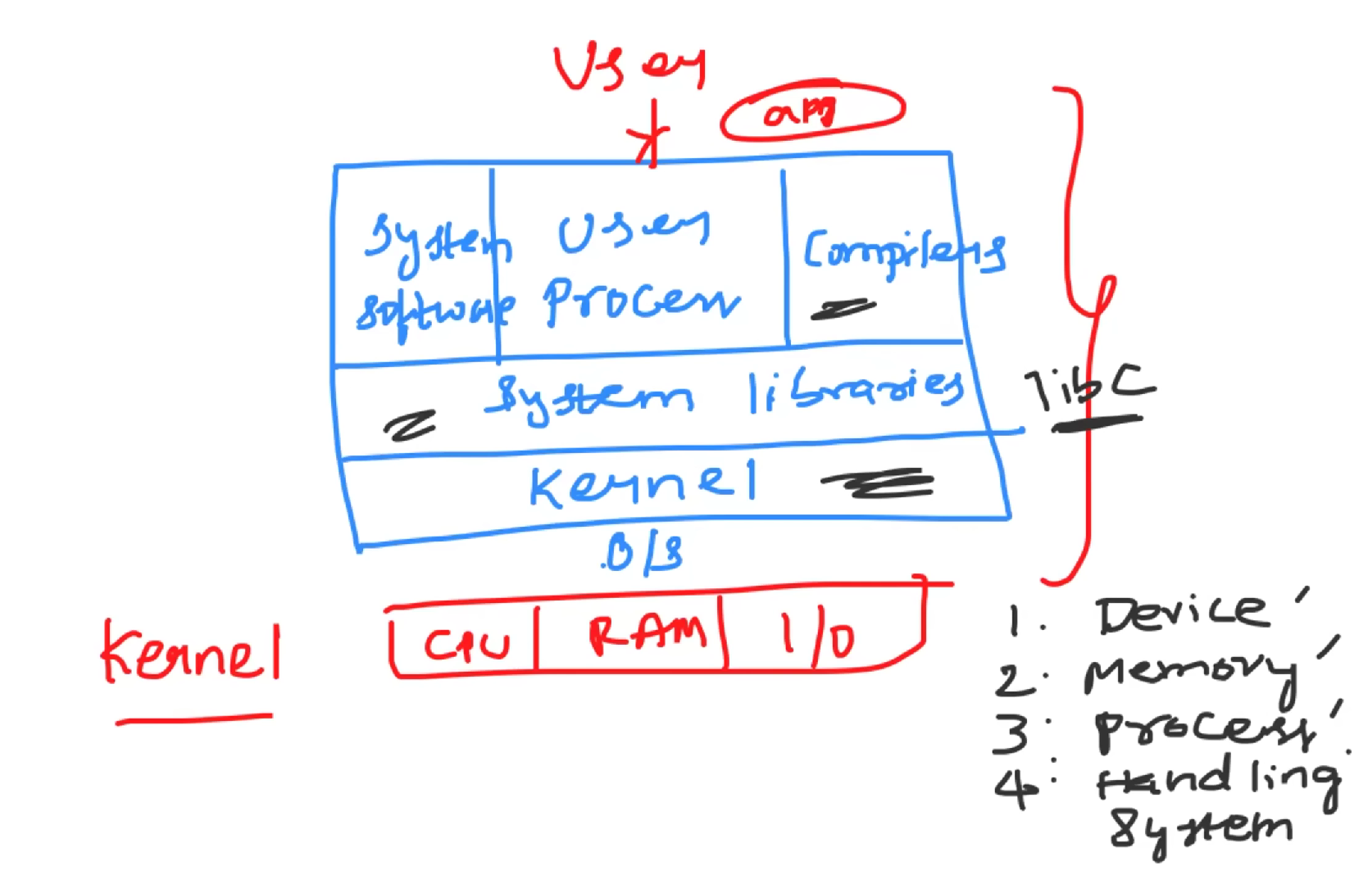

***What is kernel?***

🡪A kernel is the core part of an operating system that manages system resources and facilitates communication between hardware and software. It handles tasks like memory management, process scheduling, and device management.

**Fundamental of shell scripting**

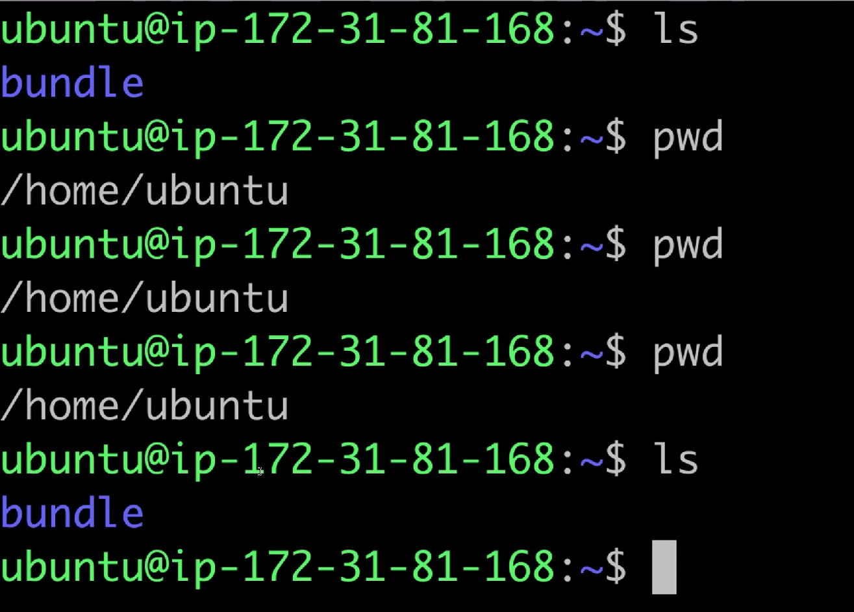

ls 🡪 list

pwd 🡪 present working directory

cd 🡪 change directory

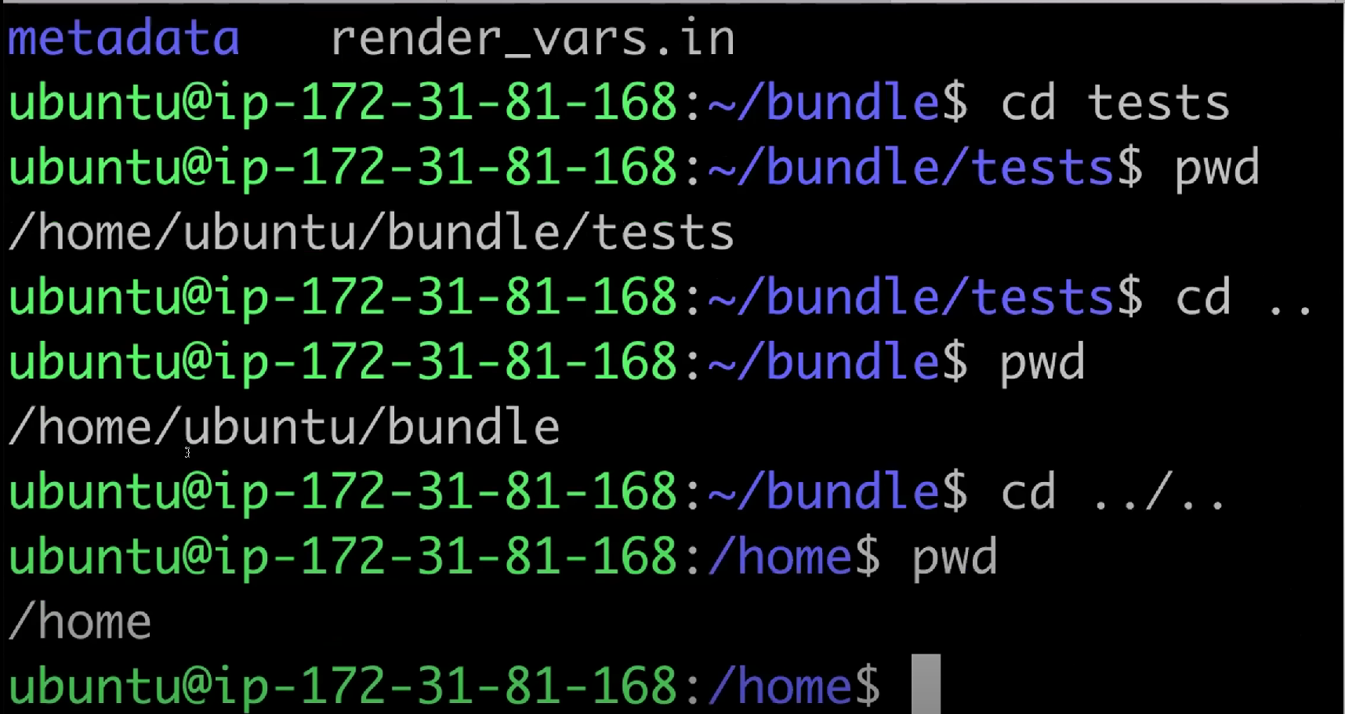

cd . . 🡪 go one step back

cd . ./. . 🡪 go two step back

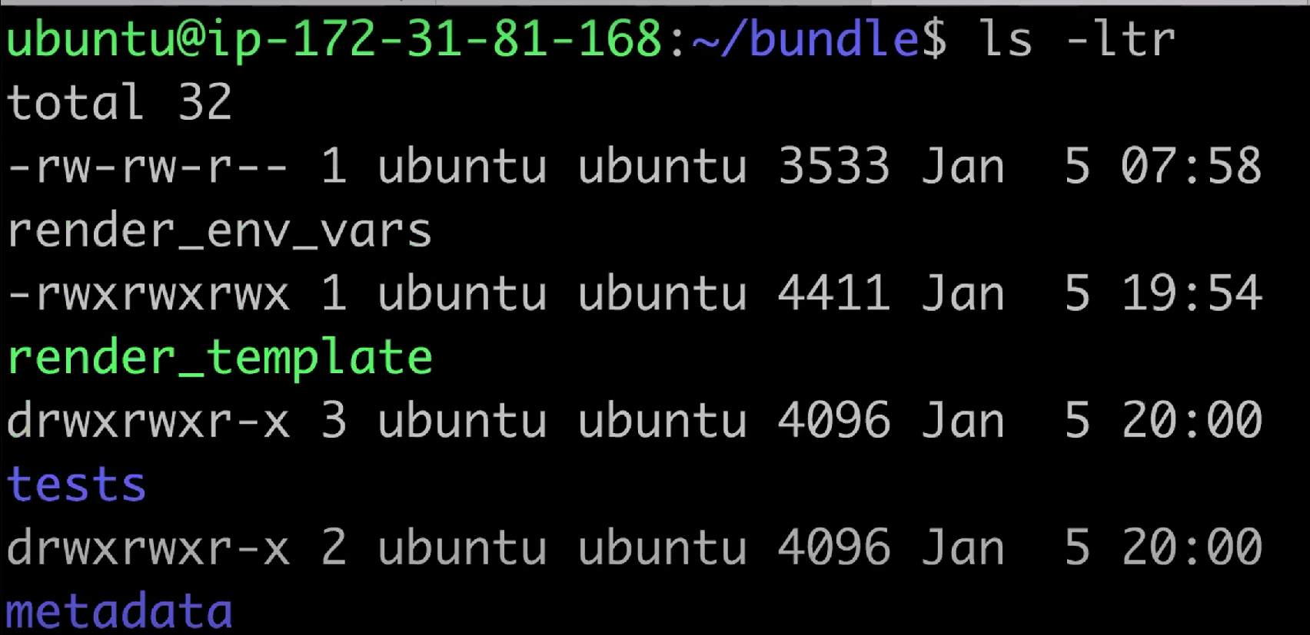

ls -ltr 🡪 detailed info like which is file which one is directory ( for e.g **tests** permissions starts with **d**rwxrwxr-x if it starts with d then it’s a directory otherwise it is file, like render_env_vars starts with **-**rwxrwxrwx) or file, owner, group owner, when its created (time stamps).

touch abhishek 🡪 create new file having name abhishek.

vi test 🡪 to create and write content inside file.

Mkdir directory_name🡪 to create directory

rm -r filename 🡪 to remove file

free -g 🡪 what is memory and storage of server

nproc 🡪 what is the number of cpu

df -h 🡪 what is the disk size

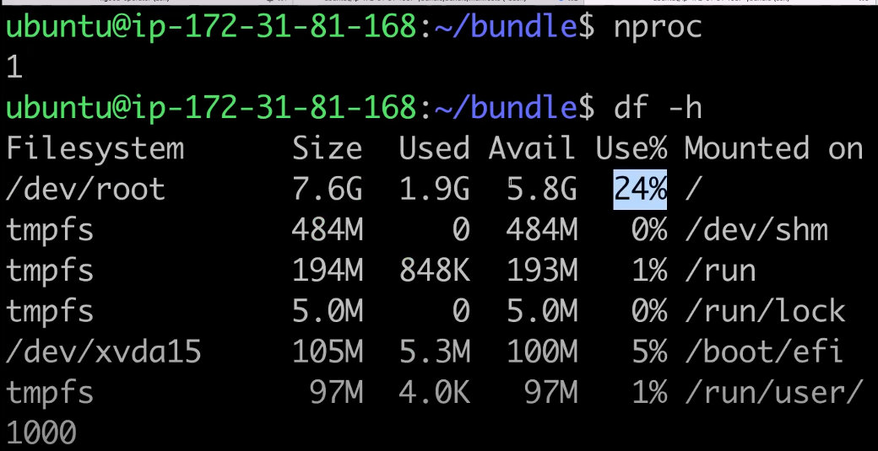

***Interview que 🡪***

top 🡪 to check monitor see our memory info and cpu usage

<https://www.youtube.com/watch?v=zsajhz2_50g&t=1264s> 🡪 shell scripting extra videos part 1

shell scripting is used for increasing automation in your day-to-day activities in Linux.

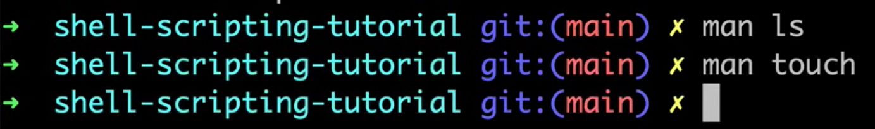

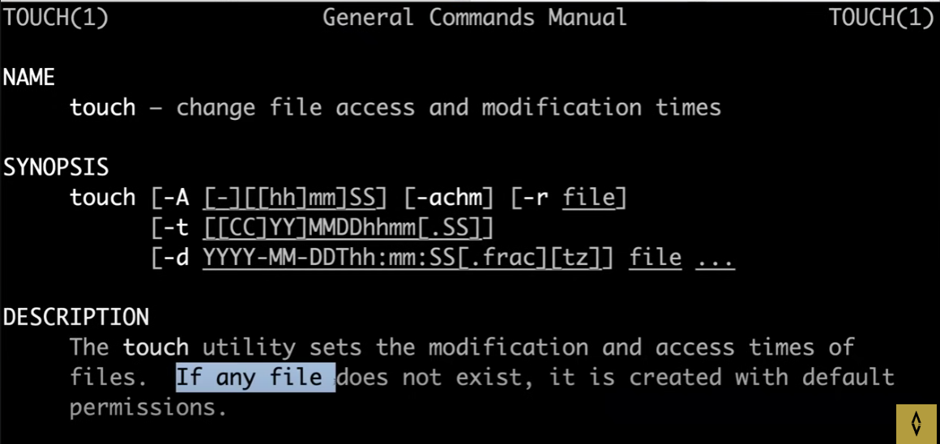

man touch 🡪 **man** command in Linux is used to display the user manual of any command that we can run on the terminal. **It provides a detailed view** of the command which includes NAME, SYNOPSIS, DESCRIPTION, OPTIONS, EXIT STATUS, RETURN VALUES, ERRORS, FILES, VERSIONS, EXAMPLES, AUTHORS and SEE ALSO.

vi filename / vim filename 🡪 to create, open and edit file

#!/bin/bash 🡪 shebang

#!/bin/ksh

#!/bin/sh

#!/bin/dash

/ksh, /sh, /bash 🡪 executables

***what is the difference between # /bin/sh and # /bin/bash?***

🡪 - `#!/bin/sh`: Runs a basic shell that's compatible with many systems; it's good for portability.

- `#!/bin/bash`: Runs Bash, which has more features and tools but might not work everywhere.

Use `sh` for simpler scripts and `bash` when you need extra capabilities.

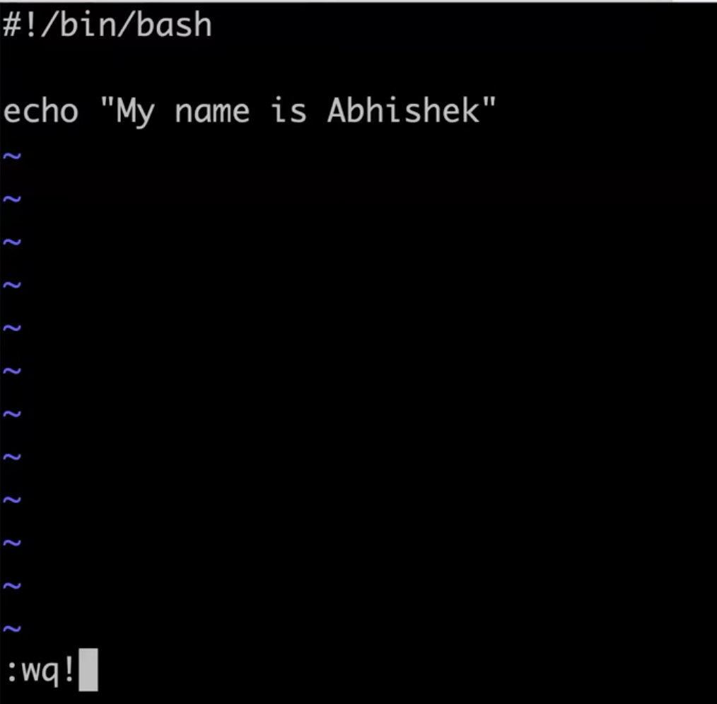

echo “message”🡪 to print any texts in “ ”. (in this case message will print)

:wq! 🡪 to save file and come out of edit mode

:q 🡪 to quit the file and come out of editing mode

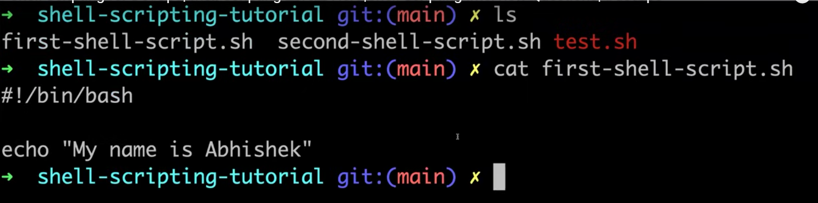

cat filename 🡪 to print text in filename file.



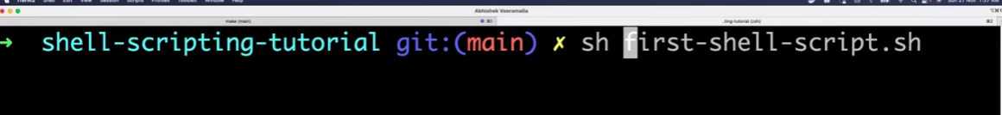

./ filename or sh filename 🡪to execute Any executable file

chmod 🡪 grants permissions to file

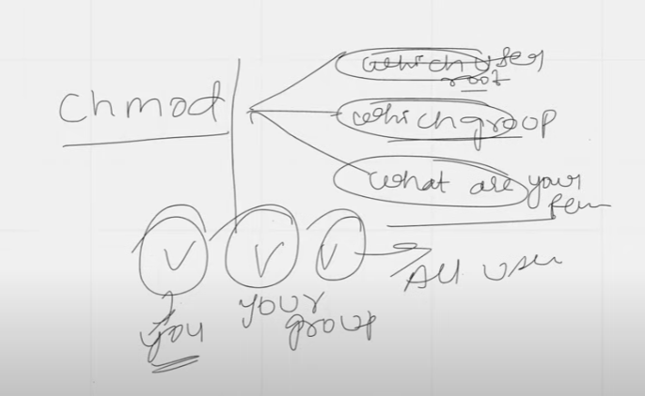

4 🡪 READ

2 🡪 WRITE

1 🡪 EXECUTE

Here are some `chmod` examples with different combinations of permissions and their explanations:

1. chmod 777 file.txt

- Gives everyone (owner, group, others) full permissions (read, write, execute).

2. chmod 644 file.txt

- Owner can read and write; group and others can only read.

3. chmod 600 file.txt

- Only the owner can read and write; no access for group and others.

4. chmod 755 script.sh

- Owner can read, write, and execute; group and others can read and execute.

5. chmod 400 secret.txt

- Only the owner can read; no permissions for group and others.

6. chmod 500 program

- Owner can read and execute; group and others have no permissions.

7. chmod 300 file

- Owner can write and execute; group and others have no permissions.

8. chmod 111 file

- Everyone can only execute; no read or write permissions.

These combinations help control who can read, write, or execute files!

Why shell scripting is used?

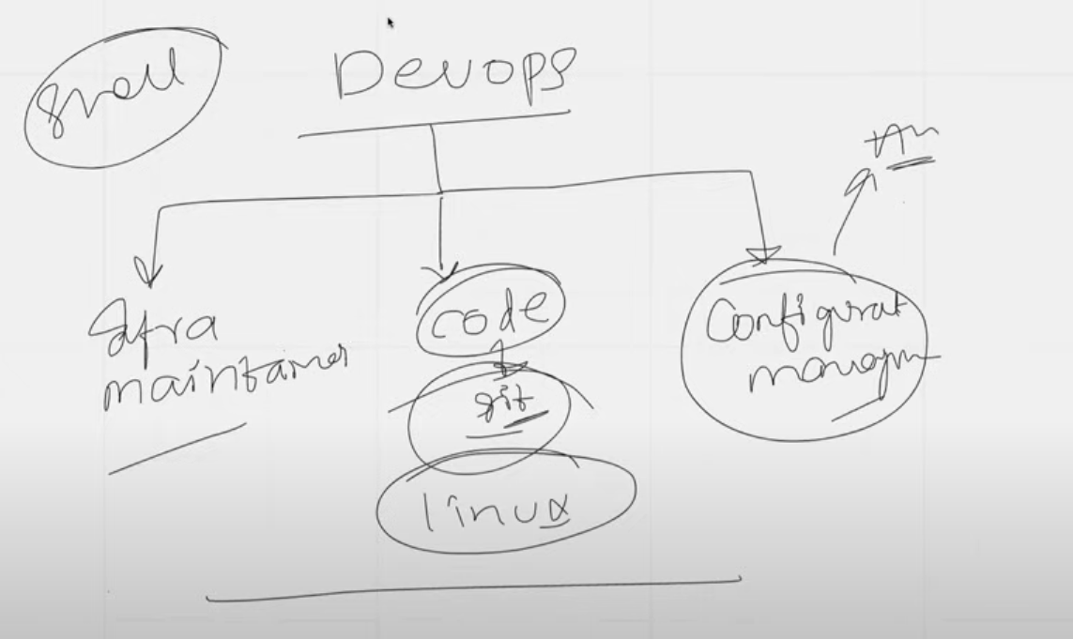

<https://youtu.be/CyQtk9f646Q?si=r04Ry_CZksO9wqEM> 🡪 shell scripting extra videos

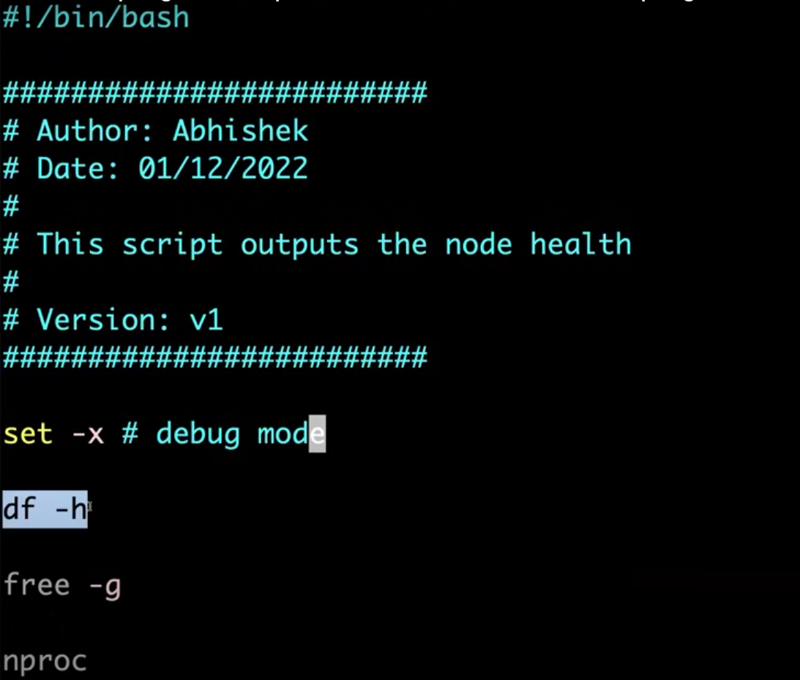

set -x # debug mode

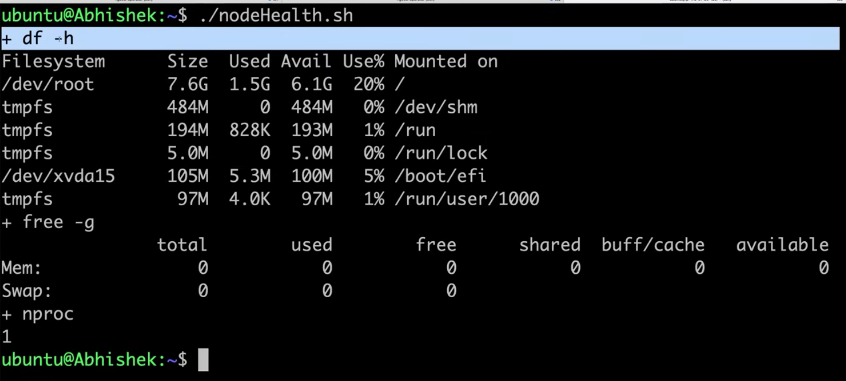

ps -ef 🡪 printing all the information of running processes

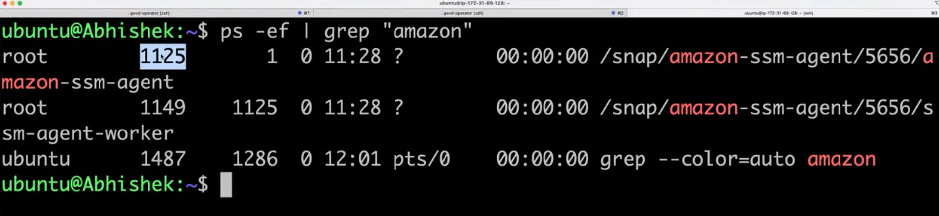

grep 🡪 fetches info that needed

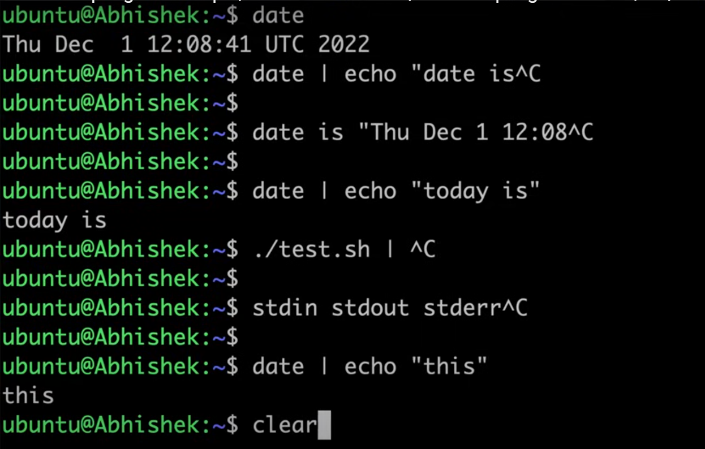

***Interview question***

***Why date is not printed in above scenario?***

In the command `date | echo "this"`, the output of the `date` command is piped into the `echo` command. However, `echo` does not read from standard input (stdin) when used in this way; it simply outputs its arguments.

So, in this case, `echo` only prints "this" and ignores any input it receives from the pipe. That's why the date is not printed. If you want to display both the date and "this," you could use:

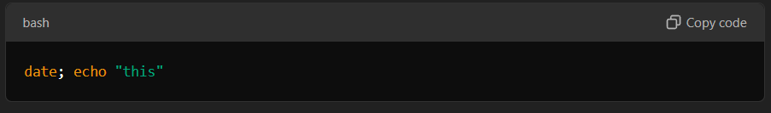This way, the `date` command executes first, prints the date, and then `echo` outputs "this."

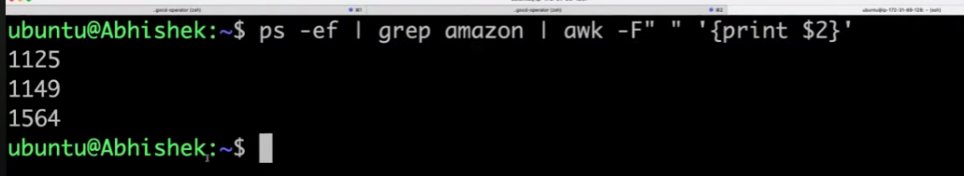

The command `ps -ef | grep amazon | awk -F" " '{print $2}'` is a pipeline that combines several commands to list process IDs (PIDs) of processes related to "amazon." Here's a breakdown of the `awk` part:

1. `awk -F" "`: This tells `awk` to use a space as the field separator. The `-F` option specifies the delimiter that separates columns in the input text.

2. `'{print $2}'`: This is the action `awk` performs on each line of input. `$2` refers to the second field (or column) of the input line. So, `print $2` outputs the value of the second field.

### Full Explanation of the Pipeline

- `ps -ef`: This command lists all running processes in a full-format listing. Each line includes various pieces of information about each process, including the PID.

- `grep amazon`: This filters the output of `ps -ef` to include only lines that contain the string "amazon," effectively showing only processes related to that term.

- awk -F" " '{print $2}': Finally, this processes the filtered output from `grep`. It uses spaces to separate fields and prints the second field, which corresponds to the PID of the matching processes.

### Summary

Overall, the command extracts and prints the PIDs of processes related to "amazon" from the list of all running processes.

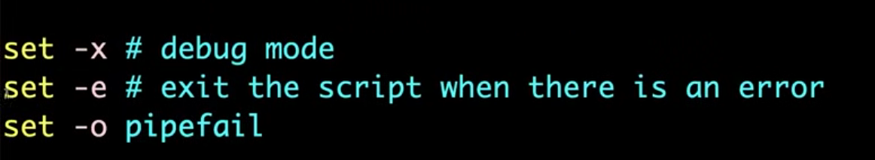

**The commands `set -e` and `set -o pipefail` are used in shell scripting to control the behavior of the script, especially regarding error handling. Here's what each one does**:

1. set -e: This option tells the shell to immediately exit if any command in the script returns a non-zero exit status (indicating an error). This is useful for ensuring that errors are caught early, preventing the script from continuing in an unintended state.

2. set -o pipefail: This option changes the behaviour of pipelines. By default, in a pipeline, only the exit status of the last command is considered. With `pipefail`, if any command in the pipeline fails (returns a non-zero exit status), the entire pipeline fails, and the return status reflects that failure. This is important for error handling in scripts that use pipes.

Using both of these options together helps ensure that scripts are robust and handle errors appropriately. If any command fails, the script will stop executing, making it easier to debug and maintain.

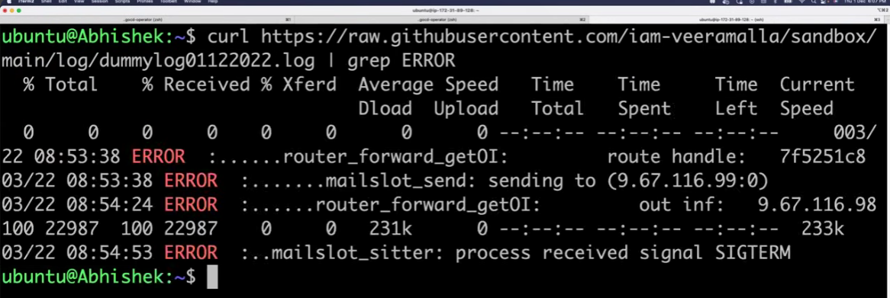

**In shell scripting, `curl` is used to interact with web services. Here are some common uses:**

1. **Fetch content**: `content=$(curl -s http://example.com)`

2. **Download a file**: `curl -O http://example.com/file.txt`

3. **Send POST data**: `curl -X POST -d "name=value" http://example.com/api`

4. **Check HTTP status**: `response=$(curl -o /dev/null -s -w "%{http_code}\n" http://example.com)`

5. **Use a variable**: `url="http://example.com"; curl "$url"`

It allows for automated requests and data retrieval in scripts.

***Interview question***

***what is the difference between wget and curl command?***

Here’s a brief comparison of wget and curl:

- Purpose:

- wget: Mainly for downloading files, including recursive downloads.

- curl: For making various types of requests (GET, POST) and interacting with APIs.

- Protocol Support:

- wget: Supports HTTP, HTTPS, and FTP.

- curl: Supports many protocols (HTTP, HTTPS, FTP, SFTP, etc.).

- Output:

- wget: Downloads files to the current directory.

- curl: Outputs data to the terminal by default.

- Retry and Error Handling:

- wget: Can automatically retry downloads.

- curl: Requires manual error handling in scripts.

In summary, use wget for straightforward downloads and curl for complex web interactions.

**trap command**

The trap command in shell scripting is used to run specific commands when the script receivescertain signals. This is useful for handling interruptions or performing cleanup tasks

### Basic Usage

- You can use it like this: `trap COMMAND SIGNAL`

### Example

If you write:

```bash

trap 'echo "Script interrupted"; exit' SIGINT

```

When you press Ctrl+C, it will print "Script interrupted" and then exit the script.

### Key Points

- trap can respond to signals like SIGINT (interrupt) or SIGTERM (terminate).

- You can set it up to handle multiple signals.

- It's often used to clean up resources, such as deleting temporary files, before the script exits.

In short, trap helps manage what happens when your script is interrupted or encounters certain events.

**Shell Scripting & Linux Interview Questions for DevOps Engineers**

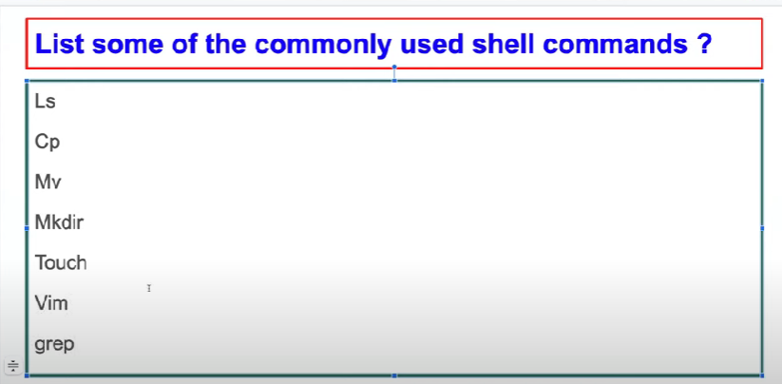

**write the script for printing only errors from remote log.**

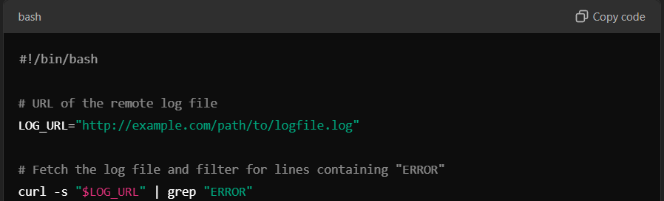

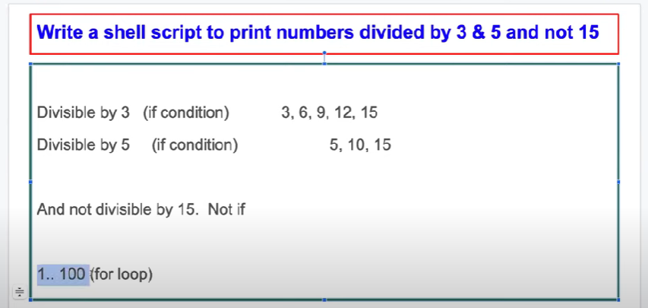

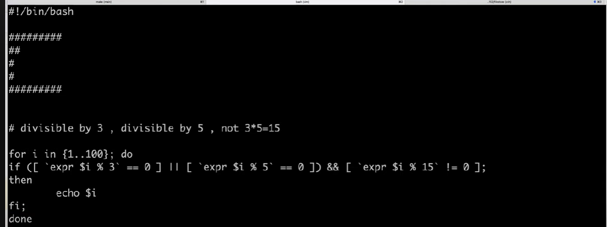

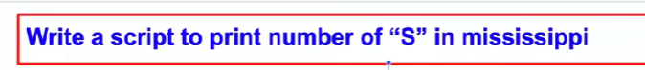

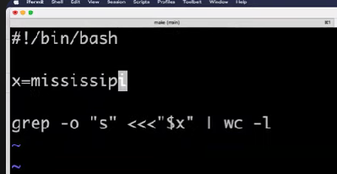

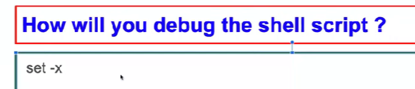

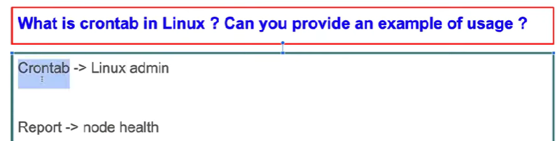

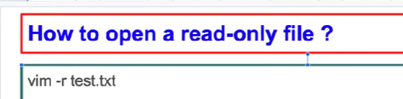

**Use -r to open file in read only mode**

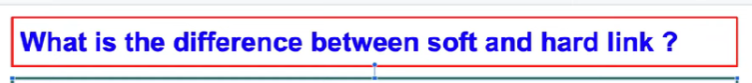

**In Linux, the differences between soft links (symbolic links) and hard links are:**

**1. Definition:**

**- Soft link: Points to a file or directory by pathname (acts like a shortcut).**

**- Hard link: Directly references the inode of a file.**

**2. Behavior:**

**- Soft link: Becomes broken if the original file is deleted.**

**- Hard link: Remains valid even if the original file is deleted.**

**3. Cross-filesystem Linking:**

**- Soft link: Can link to files across different filesystems.**

**- Hard link: Can only link to files on the same filesystem.**

**4. Directory Linking:**

**- Soft link: Can link to directories.**

**- Hard link: Typically cannot link to directories.**

**5. Inode Count:**

**- Soft link: Has its own inode.**

**- Hard link: Shares the inode of the original file.**

**In summary, soft links are more flexible, while hard links provide a direct connection to the file's data.**

**.**

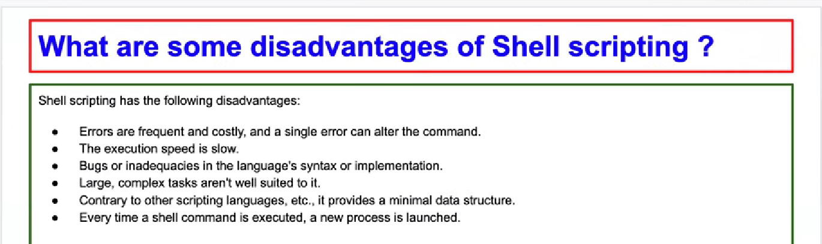

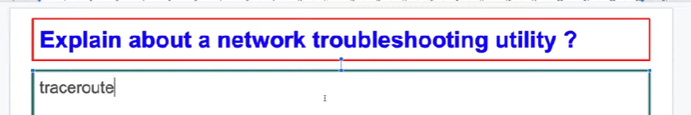

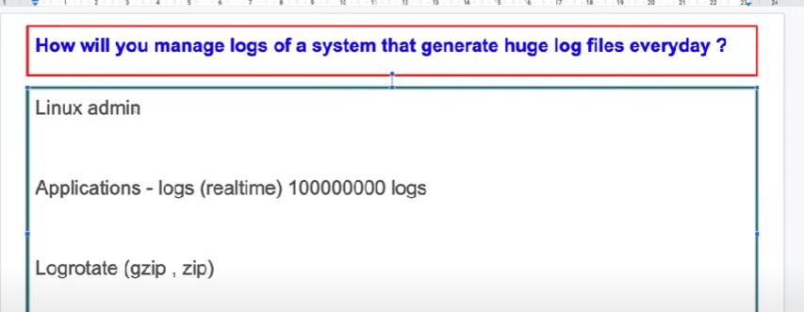

**Day-7 | Live AWS Project using SHELL SCRIPTING for DevOps**

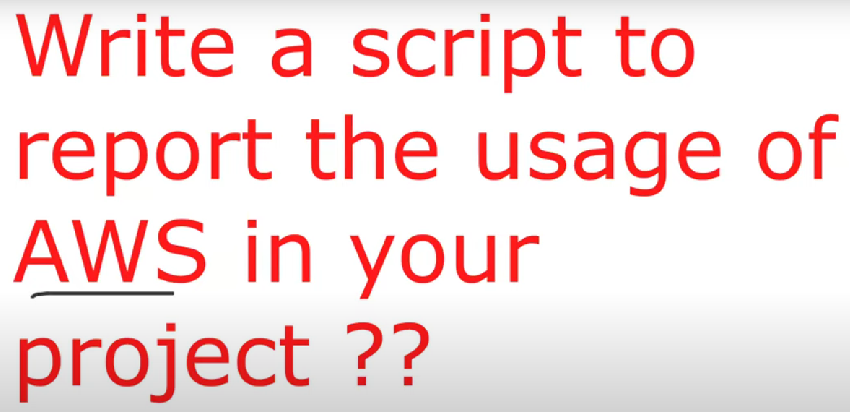

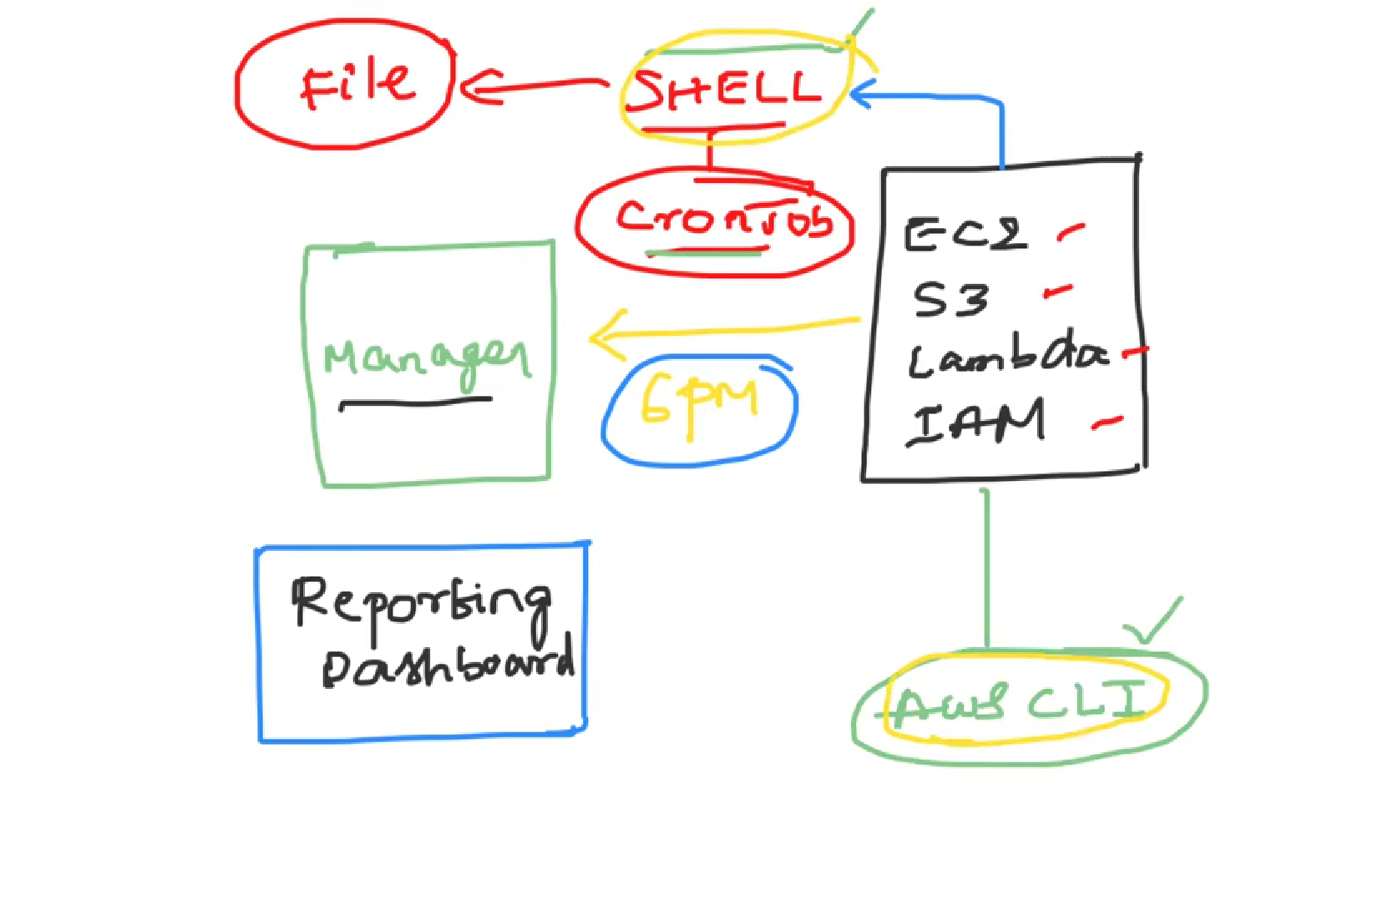

**Day-8 | DevOps Zero to Hero | Shell Scripting Project Used In Real Time**

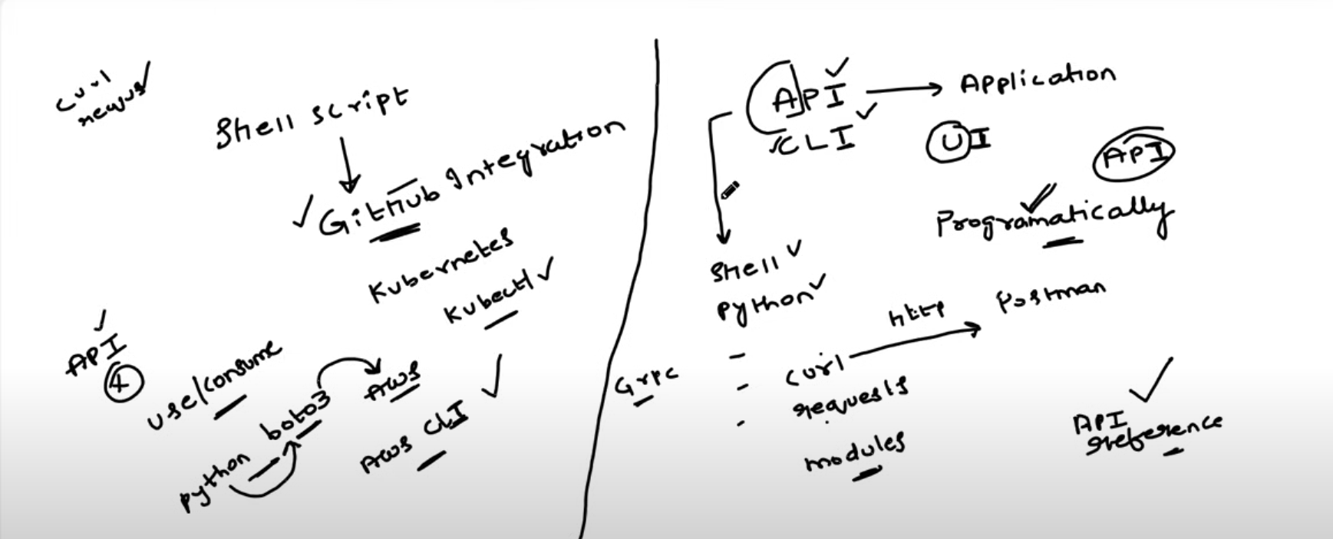

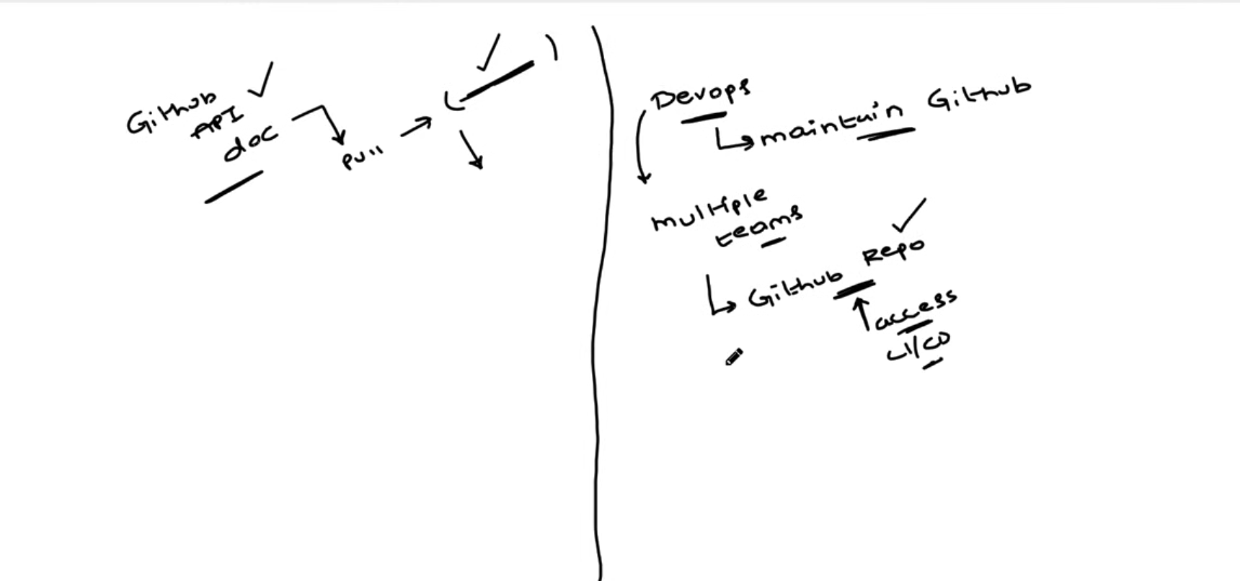

**Day-9 | Git and GitHub | What is GIT? | What is Version Control?**

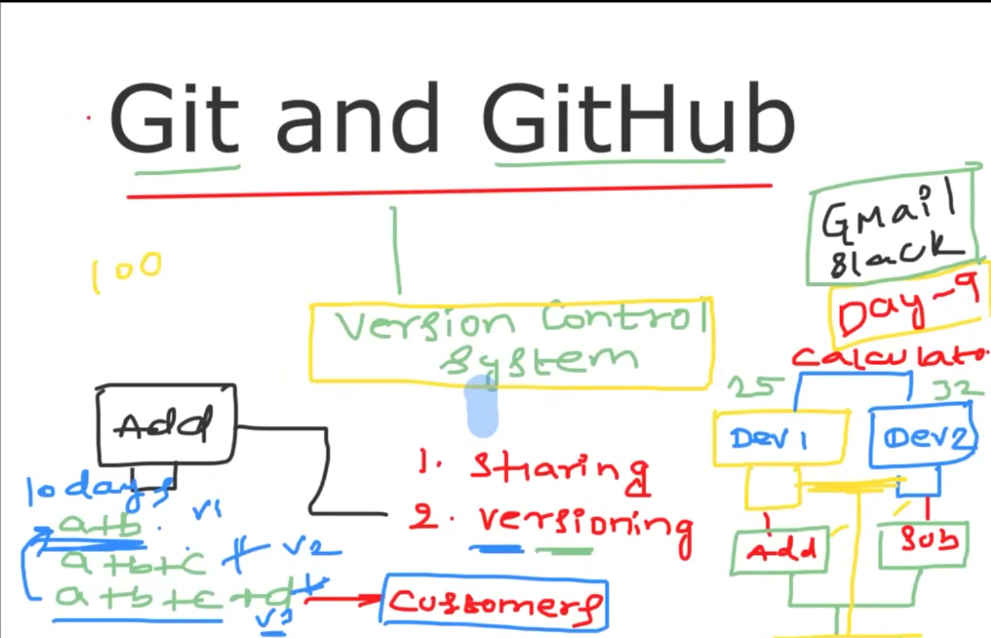

**A Version Control System (VCS) is a tool that helps manage and track changes to code over time. It allows multiple developers to collaborate, maintain a history of changes, and easily revert to previous versions of the code. There are two main types: centralized (one central repository) and distributed (each developer has their own full copy of the repository).**

**Advantages of VCS:**

1. Track changes: Keep a history of who made changes and why.

2. Collaboration: Multiple developers can work on the same project without conflicts.

3. Backup & recovery: Easily revert to previous versions of the code.

4. Branching & merging: Work on separate features without affecting the main codebase.

5. Code review: Allows for peer review before merging code.

6. Conflict resolution: Tools to handle code conflicts between developers.

7. Traceability: Understand why changes were made through commit messages.

8. Release management: Mark stable versions or releases using tags.

9. Distributed teams: Developers can work offline and sync changes later.

10. Experimentation: Try new features safely in branches without affecting the main code.

Popular VCS tools include Git (most widely used), SVN, and Mercurial.

***Interview question***

**what is the difference between centralised version control and distributed vc system?**

The difference between Centralized Version Control (CVCS) and Distributed Version Control Systems (DVCS) is how the repository and history are managed.

**Centralized Version Control (CVCS):**

- There is a single central repository that stores all versions of the project.

- Developers check out files from this central repository and only have the current version locally.

- You need to be connected to the central server to commit or access history.

- Examples: SVN, CVS.

**Distributed Version Control System (DVCS):**

- Each developer has a full copy of the repository, including the complete history of the project.

- Developers can commit, branch, and work offline, with changes synced to the central server when needed.

- Branching and merging are easier and more flexible.

- Examples: Git, Mercurial.

In short, CVCS relies on a central server for all version history, while DVCS allows each developer to have a full local copy of the repository, enabling offline work and easier collaboration. 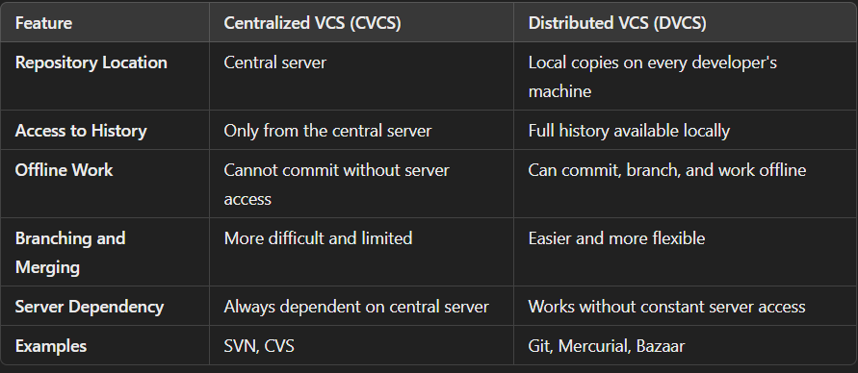

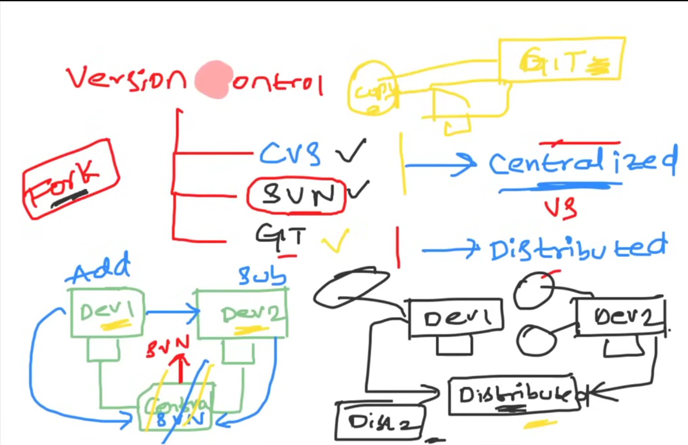

**FORK:**

In Git, a **fork** is a personal copy of someone else's repository. It allows you to make changes independently without affecting the original project. Forking is commonly used for contributing to open-source projects. After making changes in your fork, you can submit a **pull request** to propose your changes to the original repository.

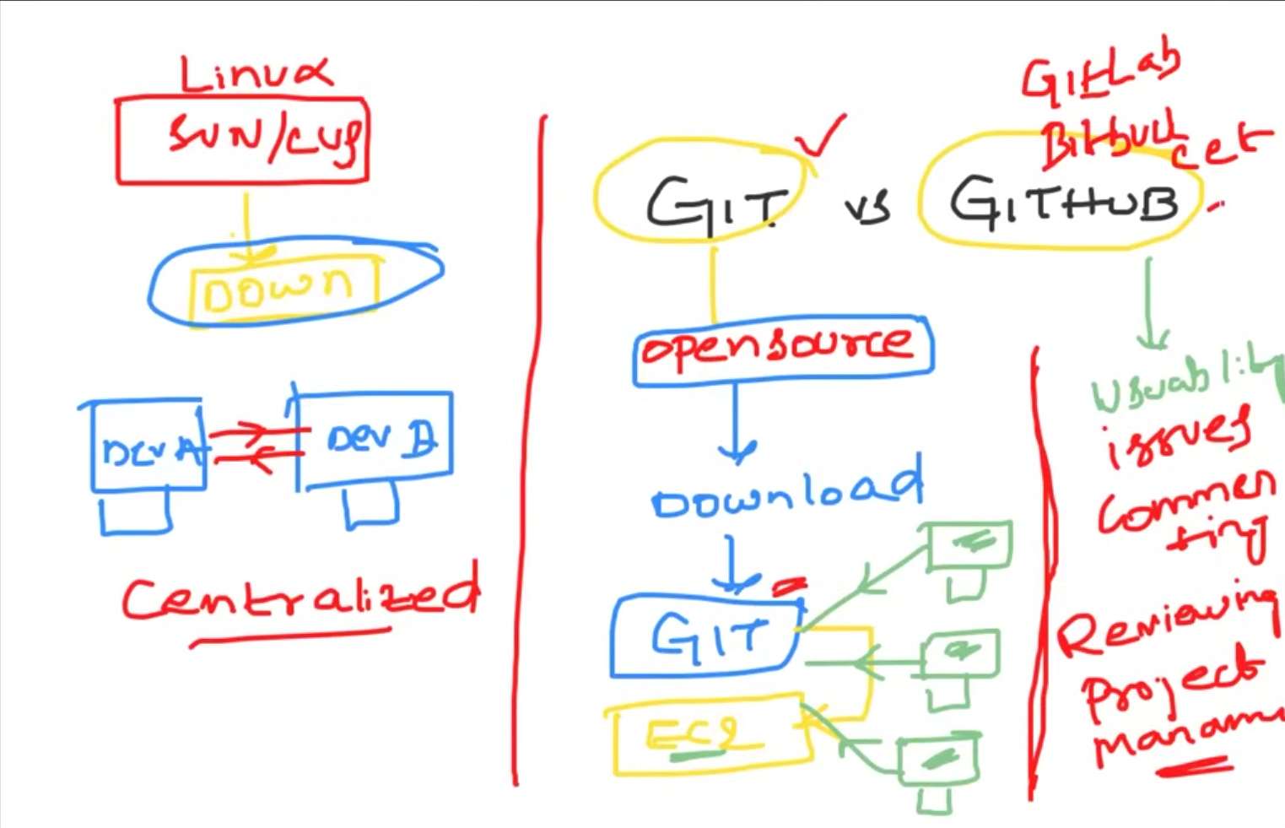

**Difference between git and github**

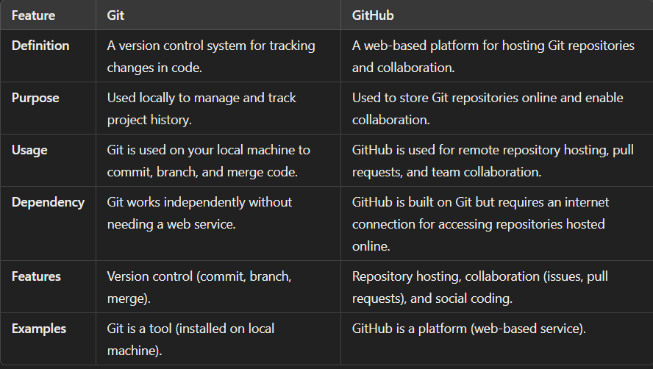



git init 🡪 initialize git repository

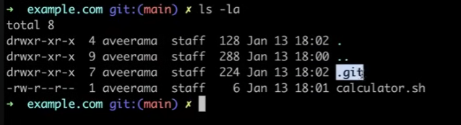after initializing git repository

ls -la 🡪 check .git folder is created 🡪 all git repo will store in this folder

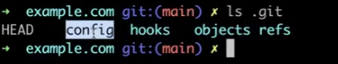

The .git folder is created when a Git repository is initialized. It contains all the configuration files and data required to track the project history and manage version control. Some key files and subfolders include:

1. config - Stores configuration settings for the repository, such as remote URLs and user preferences.

2. HEAD - Points to the current branch or commit that your working directory is based on.

3. index - Holds the staging area, where changes are prepared before committing.

4. objects/ - Contains all the objects representing the repository's data (commits, files, etc.), stored in a compressed format.

5. refs/ - Stores references to the branches, tags, and remote-tracking branches.

6. hooks - Scripts that automate tasks during Git actions (e.g., pre-commit, pre-push) for validation or notifications.

These files and folders together manage and track the history, configuration, and structure of your Git repository.

Here’s a brief explanation of each command:

**- git add:** Stages changes (new, modified, or deleted files) to be committed.

**- git status:** Displays the current state of the working directory and staging area.

**- git commit:** Records staged changes to the local repository with a message.

**- git diff:** Shows differences between the working directory and staging area, or between commits.

**- git push**: Uploads local commits to a remote repository.

**-** **git log:** Displays the commit history of the current branch.

**- git reset –hard “commitId”:** Resets the working directory and staging area to the state of the last commit, discarding any changes.

**Day-10 | Git Branching Strategy | Real World Example**

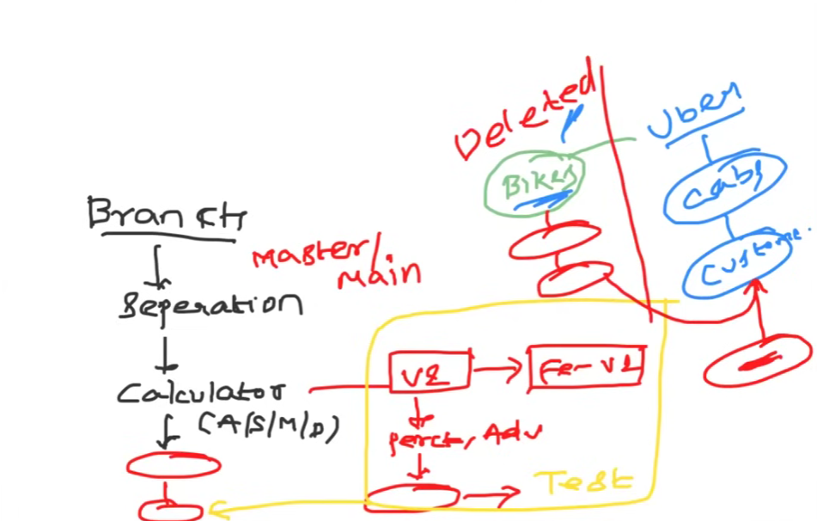

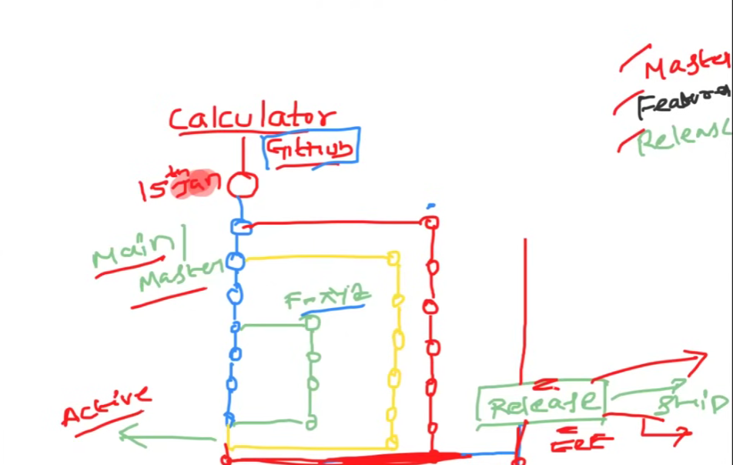

**Git branching strategy**

1. Main (or master) - The stable branch with production-ready code.

2. Develop - The branch for integrating completed features before release.

3. Feature - Branches for individual features, created from "develop" or "main."

4. Release - Prepares code for a production release, created from "develop."

5. Hotfix - Fixes urgent issues in production, created from "main."

6. Experiment - Temporary branches for testing new ideas or changes.

**Day-11 | Git Interview Q&A and Commands for DevOps**

***Interview question***

**Git clone vs fork**

